Vision-Based Hand Exercise Recognition and Feedback System for Rehabilitation

Thesis submitted to the SASTRA Deemed to be University
in partial fulfillment of the requirements
for the award of the degree of

B. Tech. Electronics & Instrumentation Engineering

Submitted by

Balaji M
(Reg. No.: 126006058)

May 2026



SCHOOL OF ELECTRICAL & ELECTRONICS NGINEERING
THANJAVUR, TAMIL NADU, INDIA – 613 401

SCHOOL OF ELECTRICAL & ELECTRONICS ENGINEERING
THANJAVUR – 613 401

Bonafide Certificate

This is to certify that the thesis titled “Vision-Based Hand Exercise Recognition And Feedback System For Rehabilitation” submitted in partial fulfillment of the requirements for the award of the degree of B. Tech. Electronics & Instrumentation Engineering to the SASTRA Deemed to be University, is a bona-fide record of the work done by Mr. Balaji M(Reg. No. 126006058) during the Eighth semester of the academic year 2025-26, in the School of Electrical & Electronics Engineering, under my supervision. This thesis has not formed the basis for the award of any degree, diploma, associateship, fellowship or other similar title to any candidate of any University.
Signature of Project Supervisor : 
Name with Affiliation : Dr. Nirmala Jegadeesan, Asst. Professor – II
Date : 27-04-2026

Project Viva voce held on ________________

Examiner 1 Examiner


SCHOOL OF ELECTRICAL & ELECTRONICS ENGINEERING
THANJAVUR – 613 401

Declaration

I declare that the thesis titled “Vision-Based Hand Exercise RecognitionAnd Feedback SystemFor Rehabilitation” submitted by me is an original work done by me under the guidance of Dr.Nirmala Jegadeesan, Asst. Professor – II, School of Electrical and Electronics Engineering, SASTRA Deemed to be University during the Eighth semester of the academic year 2025-26, in theSchool of Electrical and Electronics Engineering. The work is original and wherever I have used materials from other sources, I have given due credit and cited them in the text of the thesis. This thesis has not formed the basis for the award of any degree, diploma, associate-ship, fellowship or other similar title to any candidate of any University.

Signature of the candidate(s) :

Name of the candidate(s) : Balaji M
Date : 27-04-2026

Acknowledgements

I express my gratitude to honorable Prof. R. Sethuraman, Chancellor and Dr. S. Vaidhyasubramaniam, Vice Chancellor, SASTRA Deemed to be University for the opportunity of pursuing my engineering in this esteemed institution and carrying out the project work.

I thank Dr. R. Chandramouli, Registrar, SASTRA Deemed to be University for granting permission and extending the facilities in carrying out this project.

I express my sincere thanks and gratitude to Dr. K. Thenmozhi, Dean, SEEE, Dr. Sridhar K, Dean (Research), Dr. A. Krishnamoorthy, Associate Dean (Academics), SEEE, Dr. V. Muthubalan, Associate Dean (Research), SEEE, Dr. K. Vijayarekha, Associate Dean (Student Welfare), and Dr. Manigandan N. S, Associate Dean (Infrastructure), SEEE, SASTRA Deemed to be University, for their support in the accomplishment of my work.

I would like to express my sincere gratitude to my guide, Dr.Nirmala Jegadeesan, SASTRA Deemed to be University, whose invaluable guidance and support enabled me to successfully complete this project. Her emphasis on experiential learning allowed me to grow through my mistakes, deepen my understanding of scientific concepts in power electronics and electric vehicles, and enhance my ability to analyze and interpret results.

I also thank the project review panel members, Dr. Santhi R, Asst. Professor – II and Dr. Jayant Sharma, Asst. Professor – II School of Electrical and Electronics Engineering, for their valuable comments and insights, which made this project better.

I would also like to thank my friends who willingly volunteered as subjects and cooperated with me in collecting real-time data for the project. Their support and participation were crucial to the successful completion of my work.

And finally, I would like to acknowledge the appreciation and support that my parents provided to ensure I faced minimal obstacles throughout the project.

Abstract

Hand paralysis is a common and life-altering complication experienced by stroke patients, often limiting their ability to perform daily activities independently. To address this issue, this project presents a vision-based hand exercise recognition and feedback system that supports rehabilitation without relying on wearable sensors. The proposed system uses a standard camera to capture hand movements and applies computer vision techniques for real-time hand landmark extraction. Using MediaPipe-based hand landmark detection, spatial features are extracted and classified using machine learning algorithms to recognize multiple predefined hand rehabilitation exercises, including wrist stretching, finger flexion, grip strengthening, thumb movements, and abduction–adduction motions. The system achieves high recognition accuracy while maintaining real-time performance. A hardware-based feedback module is integrated to provide real-time visual, auditory, and wireless feedback to the user, enhancing interaction and engagement during rehabilitation. The proposed system is non-invasive, and suitable for home-based rehabilitation environments. Experimental results demonstrate the effectiveness and reliability of the system for real-time hand exercise monitoring.


Signature of the Guide Student Reg. No:126006058
Name: Dr. Nirmala Jegadeesan Name: Balaji M

Table of Contents
Title Page No.
Bona-fide Certificate ii
Declaration iii
Acknowledgements iv
Abstract v
List of Figures viii
List of Tables ix
Abbreviations x

Chapter 1 – Introduction 1
Chapter 2 - Literature Review and Objectives 2
2.1 Review of the literature 2
2.2 Objective of the Project 4
Chapter 3 – Methodology 5
3.1 Overview 5
3.2 Block Diagram and Description 5
3.3 Components used 6
3.3.1 Arduino Uno 6
3.3.2 SD Card Module 7
3.3.3 OLED Display (I2C) 7
3.3.4 ESP-01 Wi-Fi Module 8
3.4 Hardware Setup 9
3.4.1 Integration of components 9
3.4.2 Circuit Diagram & Connections 10
3.4.3 Assembly and Enclosure 14
3.4.4 Bill of Materials (BOM) 14
3.5 Real time Data Acquisition 14
3.5.1 Protocols Followed 14
3.5.2 Data Acquisition using Python and OpenCV 16
3.5.3 Dataset Preparation 17
3.6 Normalization 18
3.6.1 Feature Extraction 18
3.6.2 Data Processing 18
Chapter 4 - Results and Discussion 20
4.1 Evaluation Metrics 20
4.2 Exercise Recognition using Machine learning 21
4.3 Model Performance Report 28
Chapter 5 - Software Implementation 31
5.1 Custom UI Creation 31
5.2 Real-Time Inference & Feedback 34
5.3 Blynk as a Cloud Platform 35
Chapter 6 – Conclusions 35
6.1 Summary of the work 35
6.2 Key Outcomes 35
6.3 Limitations 35
6.4 Future Enhancements 36
Chapter 7 – References 38
Appendix 38
7.1 Similarity Check Report

Figure No. | Title | Page No.
3.1 | Flowchart | 5
3.2 | Block Diagram | 5
3.3 | Arduino Uno R3 | 6
3.4 | Micro SD Card Reader Adapter Module | 7
3.5 | OLED Display I2C | 7
3.6 | ESP01 ESP8266 Wifi Module | 8
3.7 | Integration of components | 9
3.8 | Circuit Diagram | 10
3.9 | Abduction & adduction | 15
3.10 | Finger Flexion | 15
3.11 | Opposition | 15
3.12 | Grip Power | 15
3.13 | Bending of Knuckle | 15
3.14 | Flexion | 15
3.15 | Thumb Movement | 15
3.16 | Data Acqusition | 16
4.1 | Classification Report of Random Forest | 24
4.2 | Classification Report of XGBoost | 25
4.3 | Classification Report of KNN | 25
4.4 | Label Mapping for Confusion Matrix | 25
4.5 | Confusion Matrix (Random Forest) | 26
4.6 | Confusion Matrix (XGBoost) | 26
4.7 | Confusion Matrix (KNN) | 27
4.8 | Abduction & adduction | 29
4.9 | Finger Flexion | 29
4.10 | Opposition | 30
4.11 | Grip Power | 30
4.12 | Bending of knuckle | 30
4.13 | Flexion | 30
5.1 | Custom UI | 32
5.2 | Real-time feedback through the UI | 33
5.3-5.4 | Performancemonitored and accessible on Blynk. | 34
List of Figures

List of Tables

Table No. | Table name | Page No.
3.1 | Bill of Materials | 14
4.1 | Performance comparison | 22
4.2 | Phase wise Accuracy comparison | 23
4.3 | Performance Comparison | 23

ABBREVIATIONS

ADC - Analog-to-Digital Converter
DAC - Digital to Analog Converter
SDA - Serial Data
SCL - Serial Clock
VCC - Voltage at common collector
GND - Ground

CHAPTER 1

INTRODUCTION

Hand rehabilitation plays a highly significant and essential role in the recovery process of patients who are suffering from stroke, physical injuries, or neurological disorders that negatively impact their motor functions and hand movements. Performing hand exercises on a regular basis, along with ensuring that these exercises are executed correctly and consistently, is extremely important for regaining lost strength, improving flexibility, and restoring proper coordination of the hand muscles. However, in many real-world scenarios, patients often do not have access to continuous supervision or professional guidance during their rehabilitation process. This lack of supervision can result in incorrect execution of exercises, which may ultimately reduce the overall effectiveness of the recovery process. Conventional and traditional rehabilitation systems typically depend on wearable devices, such as sensor-based gloves, in order to monitor and track hand movements during exercise sessions. Although these systems can provide accurate data and monitoring capabilities, they often come with several practical limitations. These include high costs, discomfort during prolonged usage, and the need for regular maintenance and setup. Such limitations can make them less suitable for long-term and everyday use, particularly for patients who require a simple and convenient rehabilitation solution at home. Therefore, there is a strong need for an alternative approach that is more accessible, cost-effective, and user-friendly in nature. In order to overcome these challenges and limitations, this project proposes a vision based hand exercise feedback system for rehabilitation. The proposed system makes use of computer vision and machine learning techniques to automatically detect, analyze, and classify different hand exercises in real time using a standard camera. By eliminating the dependency on wearable sensors, the system provides a completely non-contact and non-invasive solution. It utilizes hand landmark detection methods along with trained machine learning models to accurately recognize various hand movements and exercise patterns, and subsequently provides immediate and meaningful feedback to the user. The overall design of the proposed system focuses on being simple, affordable, and convenient, making it highly suitable for home-based rehabilitation purposes. In addition to assisting users in performing exercises correctly, the system also improves user engagement by continuously providing real-time feedback and performance monitoring. Ultimately, this approach aims to enhance the effectiveness of rehabilitation while ensuring ease of use, comfort, and accessibility for a wide range of users.
CHAPTER 2
LITERATURE REVIEW AND OBJECTIVE

2.1 REVIEW OF THE LITERATURE:
[1] This paper presents a system designed for monitoring hand rehabilitation sessions either locally or remotely. The device focuses on tracking patient progress and ensuring continuous observation during therapy. It emphasizes the importance of real-time monitoring to improve rehabilitation outcomes. However, the system relies on dedicated hardware components, which may increase complexity and cost. This makes it less suitable for simple, user-friendly, home-based rehabilitation environments.
[2]This study introduces a wearable hand rehabilitation system using soft gloves embedded with sensors to accurately capture finger movements. The system enables detailed motion tracking and supports effective rehabilitation training. It utilizes flexible materials to enhance comfort while maintaining precision. However, the dependence on wearable hardware increases cost and may cause discomfort during prolonged usage, limiting its practicality for continuous, convenient, and home-based rehabilitation applications.
[3] This paper focuses on a vision-based approach for hand gesture recognition using machine learning techniques. The system detects and classifies gestures through image processing without requiring physical sensors. It improves accessibility and reduces hardware dependency, making it more user-friendly. However, the system’s performance is influenced by environmental factors such as lighting conditions and camera quality, which can affect accuracy and consistency in real-time applications.
[4] This paper explores the role of hand rehabilitation robotics in post-stroke motor recovery. It highlights how robotic systems assist patients in regaining motor function through repetitive and controlled movements. The study emphasizes improved recovery outcomes using assistive technologies. However, such robotic systems often involve complex designs and high costs, which can limit accessibility and make them less suitable for widespread home-based rehabilitation use.
[5] This study introduces mirror therapy as an effective technique for rehabilitating hemiparesis after stroke. It uses visual feedback from a mirror to stimulate motor recovery in the affected limb. The approach is simple, cost-effective, and easy to implement. However, it lacks automated monitoring and feedback mechanisms, making it difficult to track patient performance and ensure correct exercise execution during independent rehabilitation.
[6] This paper presents the effectiveness of constraint-induced movement therapy (CIMT) in improving upper extremity function after stroke. The study demonstrates significant motor recovery by restricting the unaffected limb and encouraging use of the affected one. While effective, the method requires strict supervision and patient compliance. This makes it challenging to implement consistently in home-based settings without proper monitoring and feedback systems.
[7] This study proposes a home-based multi-scene upper limb rehabilitation training and evaluation system for post-stroke patients. It integrates different training scenarios to improve engagement and recovery outcomes. The system supports performance evaluation and rehabilitation monitoring. However, it may involve complex system setup and dependency on specific hardware, which can affect usability and accessibility for patients seeking simple rehabilitation solutions at home.
[8] This paper presents a rehabilitation approach combining haptically facilitated bimanual training with augmented visual feedback for patients with moderate to severe hemiplegia. The system enhances motor recovery by providing sensory and visual cues during exercises. While effective in improving coordination and engagement, the approach relies on specialized equipment and controlled environments, which may limit its practicality for independent and home-based rehabilitation use.
[9] This study introduces a hand rehabilitation learning system using an exoskeleton robotic glove. The system assists finger movements and supports training through guided exercises. It enables precise motion control and rehabilitation monitoring. However, the reliance on robotic hardware increases system complexity, cost, and maintenance requirements, making it less accessible and potentially uncomfortable for long-term and home-based rehabilitation applications.
[10] This paper focuses on hand gesture recognition using machine learning and the Myo armband. The system captures muscle signals to classify gestures accurately. It demonstrates the effectiveness of wearable sensors in gesture detection. However, the dependency on armband devices introduces hardware constraints, including cost and user discomfort, limiting its suitability for continuous and non-invasive rehabilitation solutions.

2.2 OBJECTIVE OF THE PROJECT:
- To develop a vision-based hand rehabilitation system that can recognize and analyze hand exercises effectively, eliminating the need for wearable sensors and making the system non-invasive and easy to use
- To accurately detect, track, and classify predefined hand movements using computer vision and machine learning techniques, ensuring reliable and consistent recognition performance
- To provide real-time feedback to users on their exercise performance, helping them correct mistakes, improve movement accuracy, and enhance overall rehabilitation effectiveness
- To design a low-cost, user-friendly solution that can be easily implemented for home-based rehabilitation without requiring complex hardware setup or technical expertise
- To enable continuous monitoring and evaluation of user progress while maintaining high accuracy and reliable performance during real-time hand exercise recognition

CHAPTER 3
METHODOLOGY

The methodology outlines a structured approach followed to develop the vision-based hand rehabilitation system. It begins with a review of existing literature and selection of appropriate hand exercises, followed by systematic data collection and organization. The process includes extracting and preprocessing hand landmark features, training and evaluating machine learning models, and finally implementing real-time recognition with feedback to ensure accurate and efficient rehabilitation support.

3.1 OVERVIEW

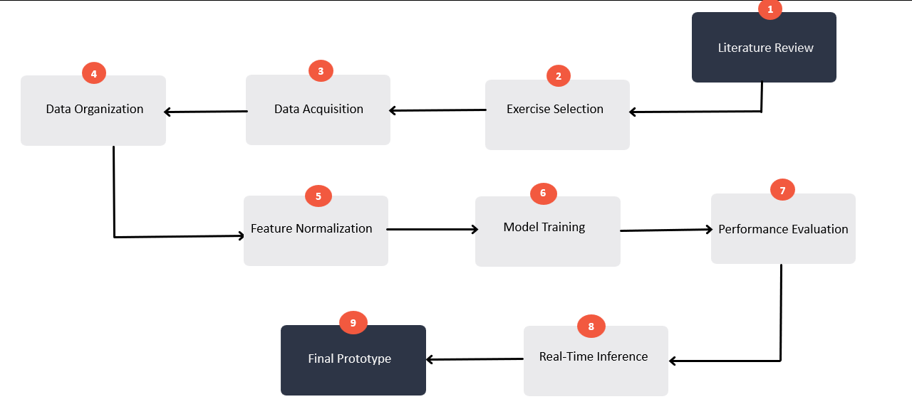
Figure 3.1. Flowchart illustrating the step-by-step methodology

3.2 BLOCK DIAGRAM AND DESCRIPTION

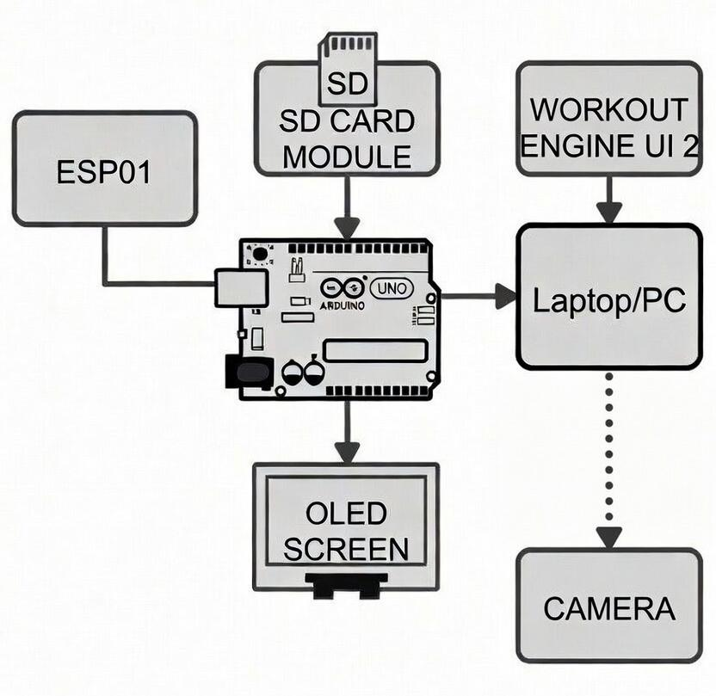

Figure 3.2. Block Diagram
This diagram illustrates the hardware architecture of the rehabilitation system. An Arduino Uno acts as the central controller, interfacing with an ESP8266 module for communication, an SD card module for data storage, and an OLED screen for displaying outputs. The Arduino is connected to a laptop/PC running the workout engine UI, which processes data from a camera for hand gesture recognition and sends feedback to the system.

3.3 COMPONENTS USED

3.3.1 Arduino Uno

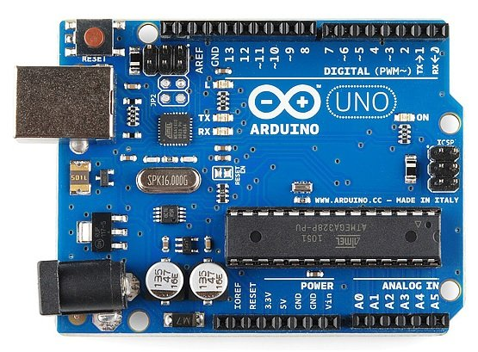

Figure 3.3. Arduino Uno R3

The Figure 3.3 shows the Arduino Uno. The Arduino Uno is a widely used, cost-effective microcontroller board based on the ATmega328P, designed for easy development of embedded and IoT applications. It supports a variety of input and output interfaces, making it suitable for interfacing with sensors, displays, and communication modules. The board operates through a simple programming environment and enables real-time control and data processing, making it ideal for prototyping and educational purposes.

• Working Voltage: 5V
• Input Voltage (recommended): 7V to 12V
• GPIO Pins: 14 digital I/O pins (6 support PWM)
• Analog Input Pins: 6 (10-bit resolution)
• Operating Current: ~50 mA typical during active use

3.3.2 SD Card Module:

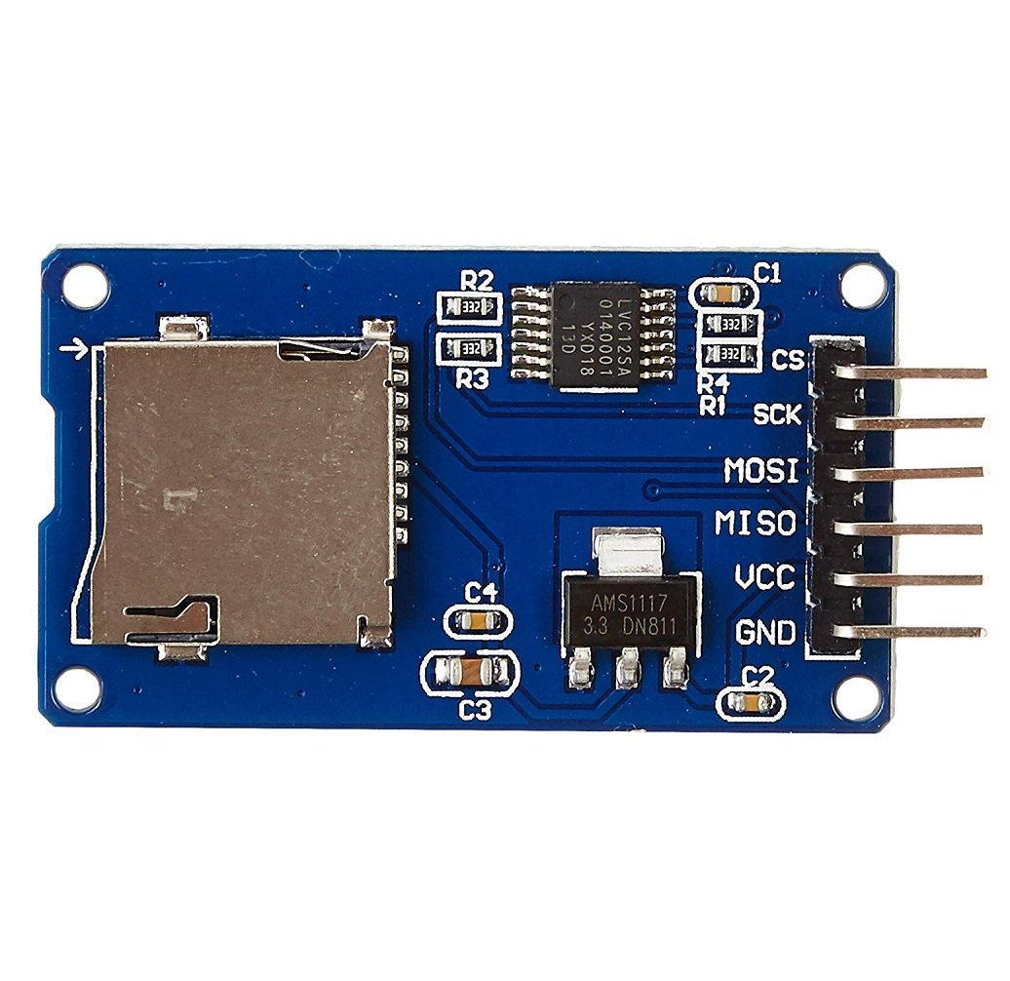

Figure 3.4. Micro SD Card Reader Adapter Module

The Figure 3.3 shows the SD Card Module. The SD Card Module is a storage interface device used to read and write data to a microSD card, enabling reliable and portable data logging in embedded systems. It communicates with microcontrollers using the SPI protocol and is commonly used for storing sensor data, logs, and system outputs. The module is compact, easy to interface, and suitable for applications requiring offline data storage and retrieval.

• Working Voltage: 3.3V (with onboard regulator supports 5V input)
• Communication Protocol: SPI (Serial Peripheral Interface)
• Supported Storage: microSD card (FAT16/FAT32 format)
• Data Transfer Speed: Up to ~25 MB/s (depending on card and SPI clock)
• Operating Current: ~50–100 mA during read/write operations

3.3.3 OLED Display:
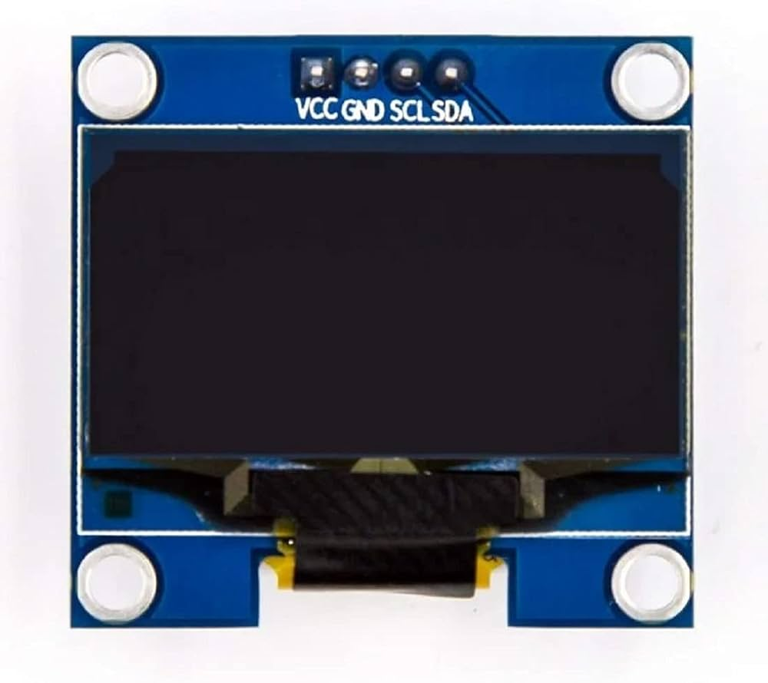
Figure 3.5. OLED Display I2C
The Figure 3.5 shows the OLED Display (I2C). The OLED display is a compact and energy-efficient output device used to present text, graphics, and real-time system information. It uses Organic Light Emitting Diode technology, which allows each pixel to emit its own light, resulting in high contrast and clear visibility without the need for a backlight. The I2C interface
reduces wiring complexity, making it easy to integrate with microcontrollers for embedded applications.

• Working Voltage: 3.3V to 5V
• Communication Protocol: I2C (2-wire interface: SDA, SCL)
• Display Resolution: Typically 128 × 64 pixels
• Power Consumption: Low (no backlight required)
• Operating Current: ~20–30 mA during active display

3.3.4 ESP-01:
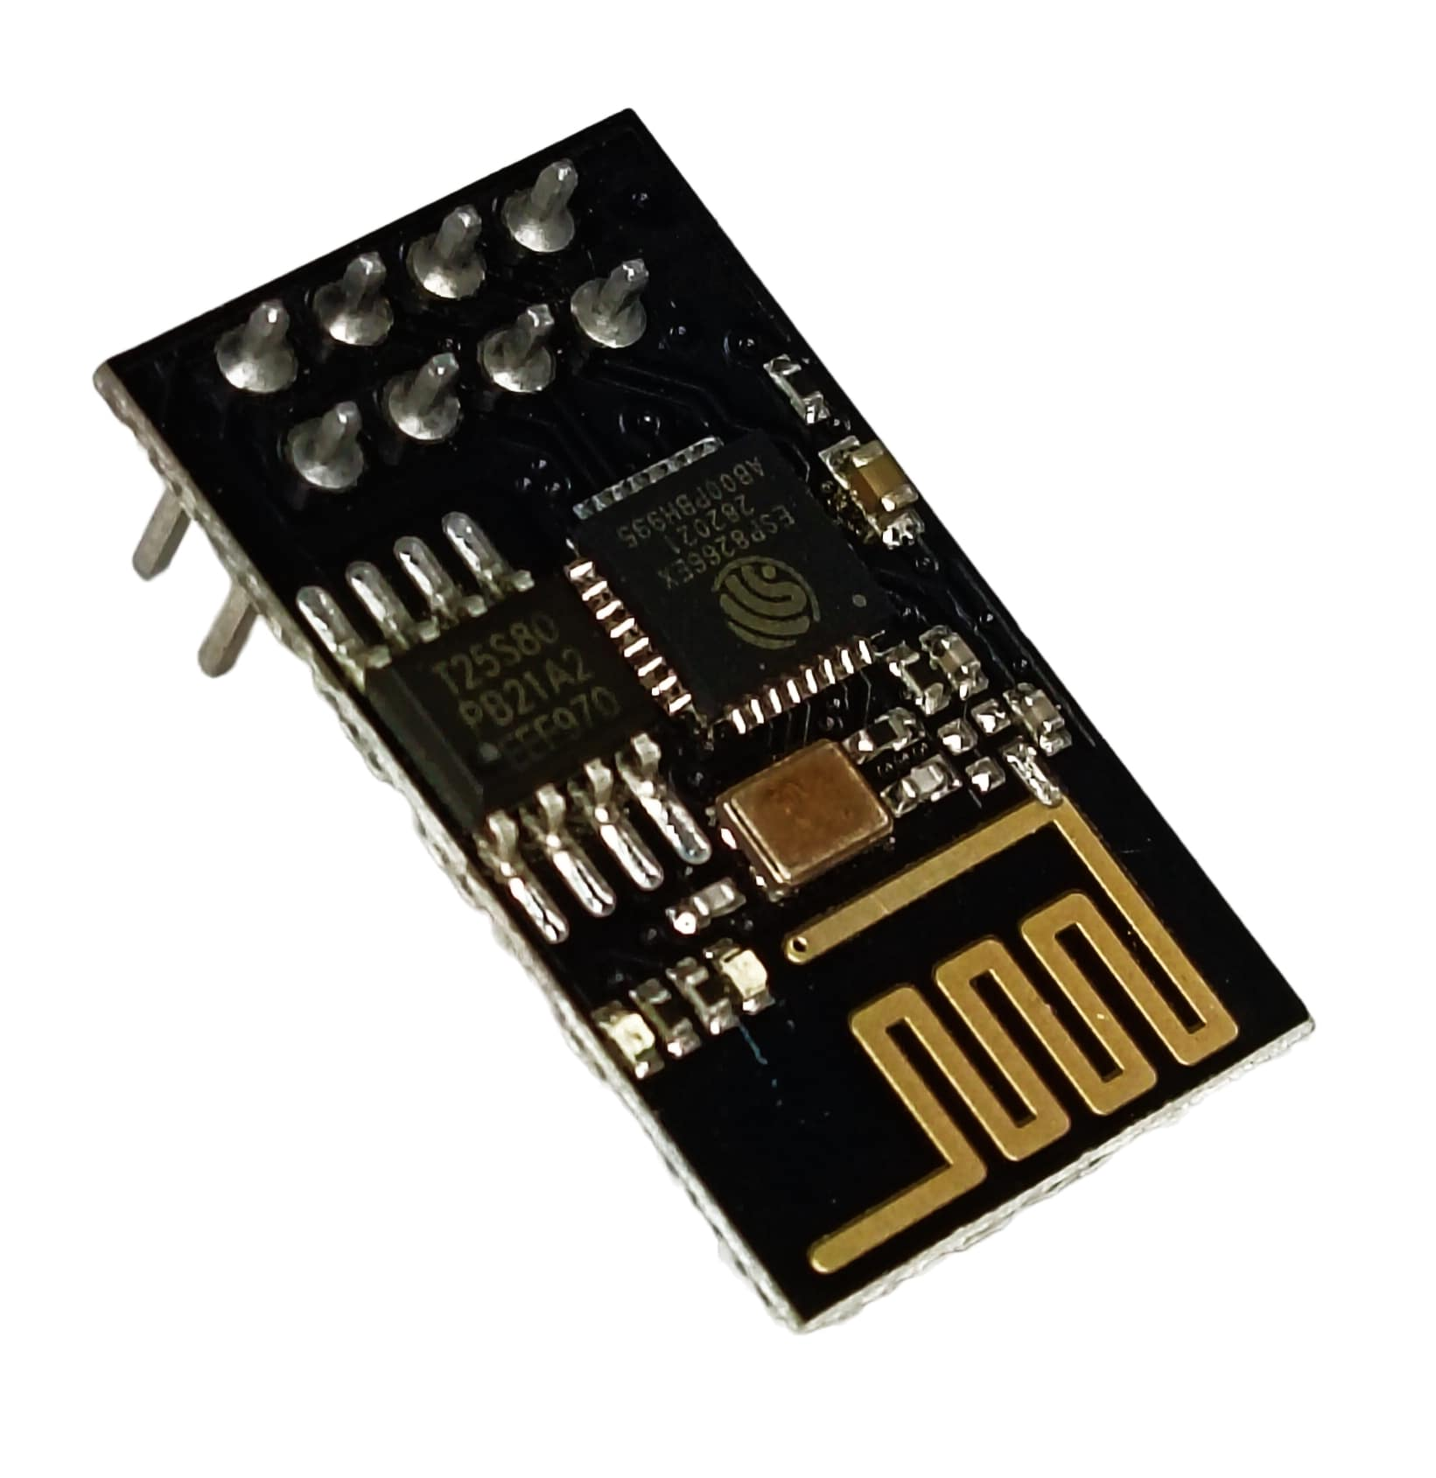
Figure 3.6. ESP01 ESP8266 Wifi Module

The Figure 3.3 shows the ESP-01 module. The ESP-01 is a compact Wi-Fi module based on the ESP8266 chipset, designed to enable wireless communication in embedded systems. It allows microcontrollers to connect to Wi-Fi networks and exchange data with IoT platforms or external applications. Despite its small size, it supports TCP/IP protocols and is widely used for remote monitoring and control applications due to its affordability and efficiency.

• Working Voltage: 3.0V to 3.6V (typically 3.3V)
• GPIO Pins: 2 (GPIO0, GPIO2)
• Communication Protocol: UART (Serial Communication)
• Wi-Fi Standard: 802.11 b/g/n
• Operating Current: ~70–200 mA during transmission

3.4 HARDWARE SETUP
3.4.1 INTERGRATION OF COMPONENTS
The integration of components ensures smooth communication between hardware and software for real-time rehabilitation feedback. The Arduino Uno acts as the central controller, interfacing with the ESP-01 Wi-Fi module, OLED display, and SD card module using UART, I2C, and SPI protocols respectively. The ESP-01 enables wireless data transmission to external applications, while the OLED provides instant visual feedback. The SD card module supports offline data logging. This integration enables efficient coordination between vision processing and hardware response.

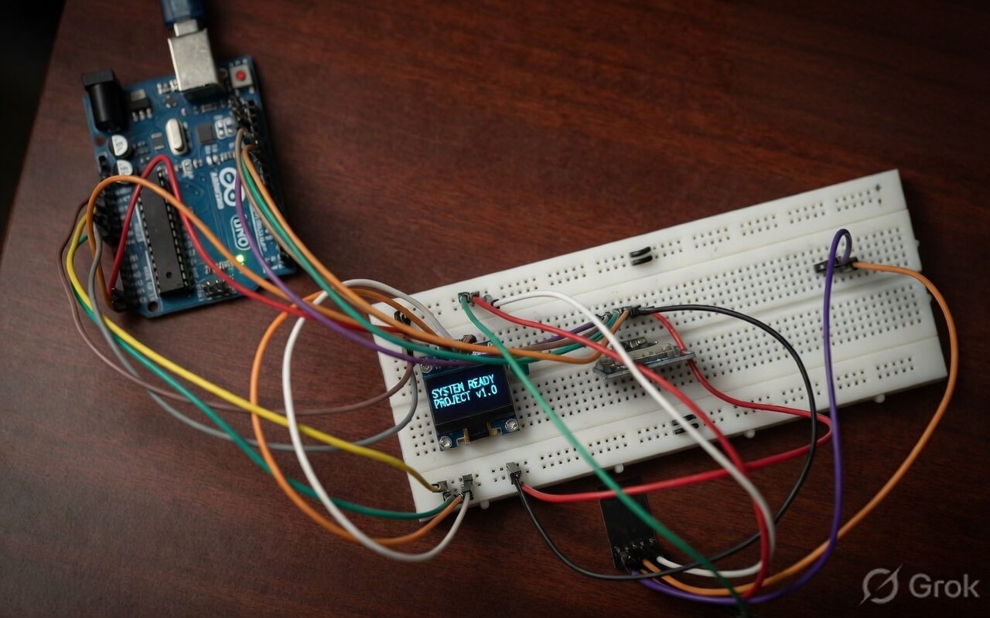
Figure 3.7. Integration of components into a system

The figure 3.7 shows the practical implementation of the system using a breadboard setup. The Arduino Uno is connected to the OLED display, ESP-01 module, and other components through jumper wires. The OLED screen displays system status, indicating successful initialization. The setup demonstrates proper power distribution and signal connections, validating the working integration of all components and confirming reliable operation of the rehabilitation system.

3.4.2 CIRCUIT DIAGRAM AND CONNECTION
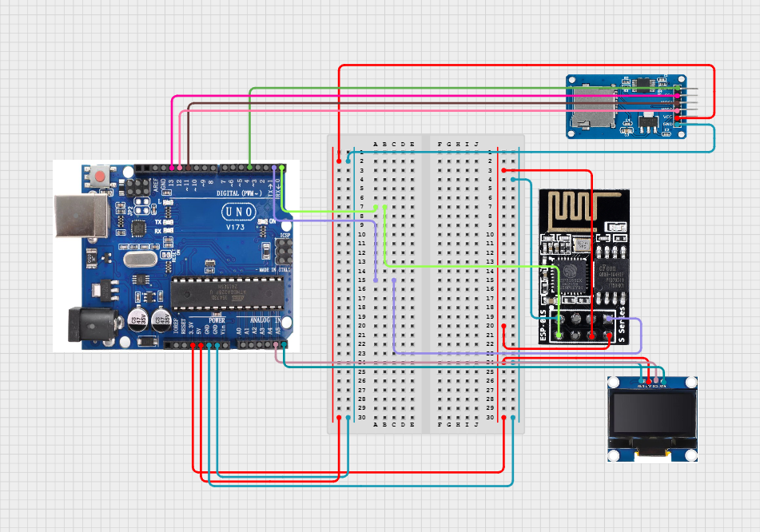
Figure 3.8.

The figure 3.8 illustrates the complete circuit diagram of the rehabilitation system, showing the interconnection between the Arduino Uno, ESP-01 Wi-Fi module, OLED display, SD card module, and supporting breadboard connections. The Arduino Uno acts as the central controller, distributing power and managing communication with all peripheral devices. The breadboard is used to simplify wiring and provide common power rails for efficient component integration.

ESP-01 Wi-Fi Module Connections
The ESP-01 module is connected to the Arduino Uno using serial communication (UART). It enables wireless data transmission between the hardware system and external applications. This connection allows the Arduino to send and receive data over Wi-Fi through the ESP-01 module.
• VCC → 3.3V (regulated supply)
• GND → GND
• TX → Arduino RX (D0)
• RX → Arduino TX (D1)

OLED Display (I2C) Connections
The OLED display is interfaced with the Arduino Uno using the I2C communication protocol, which reduces the number of required wires. It is used to display system status and output information. This setup enables efficient communication and real-time display of data.
• VCC → 5V
• GND → GND
• SDA → A4 (Arduino Uno)
• SCL → A5 (Arduino Uno)

SD Card Module Connections
The SD card module is connected to the Arduino Uno using the SPI communication protocol for data storage purposes. It allows logging of system data for later analysis. This configuration ensures reliable read/write operations between the Arduino and the SD card.
• VCC → 5V
• GND → GND
• MISO → D12
• MOSI → D11
• SCK → D13
• CS → D10

Power Distribution and Breadboard Connections
The breadboard is used to distribute power and ground connections from the Arduino to all components. The 5V and GND pins of the Arduino are connected to the breadboard rails, which supply power to the OLED display, SD card module, and ESP-01 (via regulated 3.3V if required). Jumper wires are used to establish signal connections, ensuring proper communication between all modules.
3.4.3 ASSEMBLY AND ENCLOSURE
Assembly
Breadboard and Mounting Method
To maintain a well-organized and stable hardware setup, a breadboard-based assembly is used as the central platform for integrating all components. The Arduino Uno acts as the main controller and is connected to the breadboard, where the ESP-01 Wi-Fi module, OLED display, and SD card module are interfaced. This arrangement ensures a clean layout, easy troubleshooting, and efficient connection management between all components.

Wiring and Connections
- The Arduino Uno is connected to the ESP-01 module using UART communication through TX and RX pins for wireless data transmission.
- The OLED display is interfaced using the I2C protocol by connecting SDA and SCL pins to A4 and A5 of the Arduino.
- The SD card module is connected via SPI communication using pins D10 (CS), D11 (MOSI), D12 (MISO), and D13 (SCK).
- Power connections are distributed through the breadboard, where 5V and GND from the Arduino supply all components. Jumper wires are used to establish secure and flexible connections between modules.

Component Placement and Integration
- The Arduino Uno is placed externally and connected to the breadboard for easy access and programming.
- The OLED display is positioned for clear visibility to provide real-time feedback to the user.
- The ESP-01 module is connected through a stable power source to ensure reliable Wi-Fi communication.
- The SD card module is integrated for efficient data storage and logging.

All components are arranged systematically to minimize wire complexity and improve system reliability. With this setup, the system is capable of processing data from the vision-based model and providing real-time feedback through both display and wireless communication, forming a complete rehabilitation support system.
Enclosure
Component Mounting
- The components are assembled on a breadboard, which serves as a temporary and flexible mounting platform.
- The Arduino and connected modules are placed securely to prevent loose connections during operation.
- This setup allows easy modification, testing, and debugging.
Protective Arrangement
- Since a permanent enclosure is not used, components are arranged carefully to avoid short circuits and damage.
- Proper spacing and organized wiring ensure safe and stable operation of the system.

System Design Consideration
The system is designed as a vision-based solution, which reduces the dependency on complex wearable hardware. By shifting processing to an external camera and computer, the hardware setup becomes simpler and less intrusive. This approach improves overall usability and makes the system more suitable for rehabilitation applications without adding physical burden to the user.

System Organization and Layout
The structured wiring and organized breadboard layout improve the overall clarity and functionality of the prototype. Proper arrangement of components reduces wiring complexity and minimizes connection errors. A clean and systematic setup enhances ease of use, simplifies maintenance, and provides a strong foundation for future upgrades into a more compact and enclosed design.
3.4.4 BILL OF MATERIALS(BOM)
Required  Quantity | Reference | Description | Manufacturer | Price of Single unit (₹) | Total Price  (₹)
1 | Arduino UNO | Versatile open-source microcontroller | Arduino (Italy) | 700 | 700
1 | SD Card Module | Interface for reading and writing data storage. | Adafruit | 150 | 150
1 | OLED Screen | Compact display for visual data feedback | Adafruit | 120 | 120
1 | ESP-01 | Wi-Fi module for wireless data transmission | Espressif | 180 | 180
1 | ARDUINO UNO-CON | Pin Head Connector for ESP32 | Adafruit | 80 | 80
25 | JMP-CABLE | Female-Female/  Female-Male | Adafruit | 5 | 125
1 | Bread Board | Solderless platform for temporary circuit prototyping | AS&R Circuits | 150 | 297
Total | 1652

Table3.1 Bill of Materials

3.5REAL TIME DATA ACQUISITION
3.5.1PROTOCOLS FOLLOWED
The Figures 3.9 to 3.15 depict a real-time data acquisition session where a subject performs a series of specific hand gestures designed for hand rehabilitation. The sequence captures key anatomical and functional movementsAbduction & Adduction, Finger Flexion (Fist), Opposition, Grip Power, Bending of Knuckle, Flexion, and Thumb Movement. Each frame demonstrates the system's ability to prompt the user and capture distinct kinematic patterns, showing how the interface tracks and categorizes complex hand orientations and grip strengths.

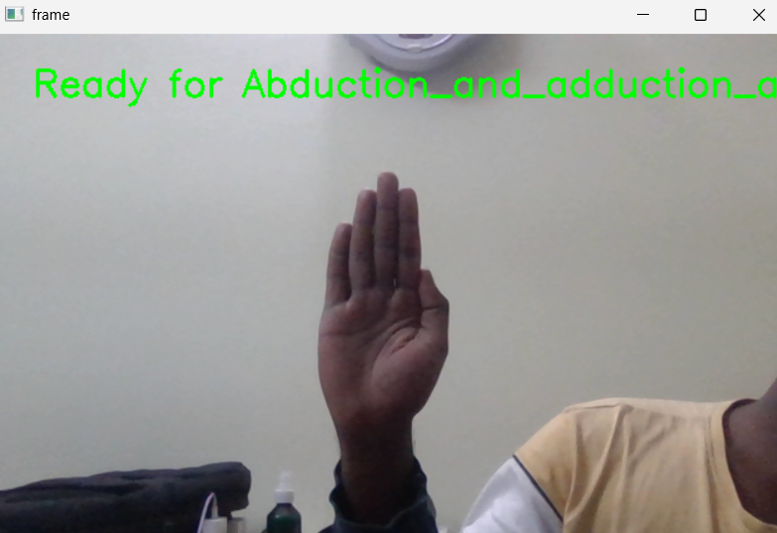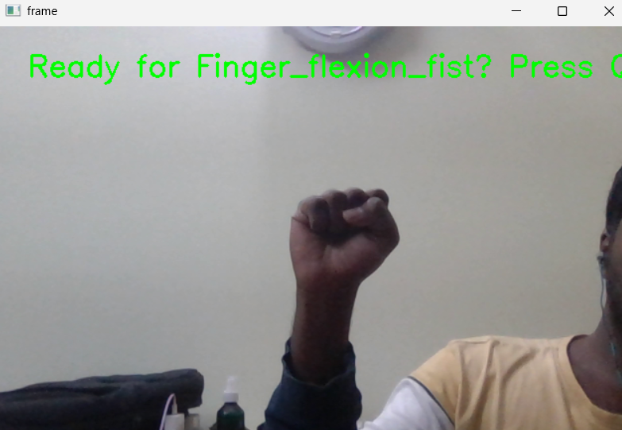
Figure 3.10. Finger Flexion

Figure 3.9. Abduction & adduction

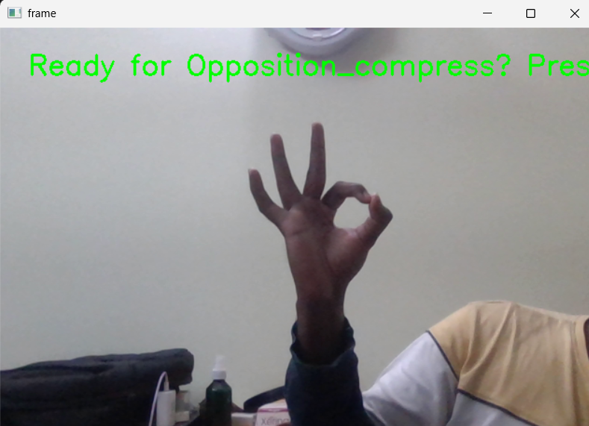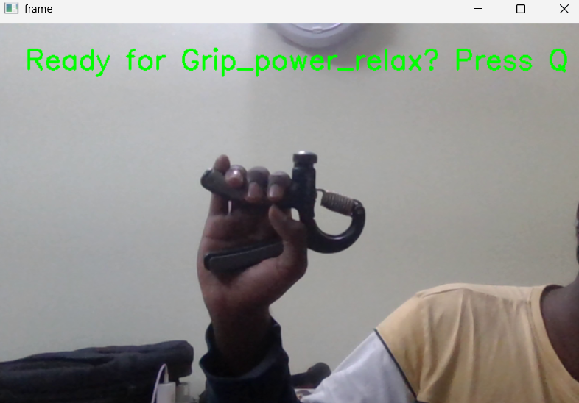
Figure 3.12 Grip Power

Figure 3.11. Opposition

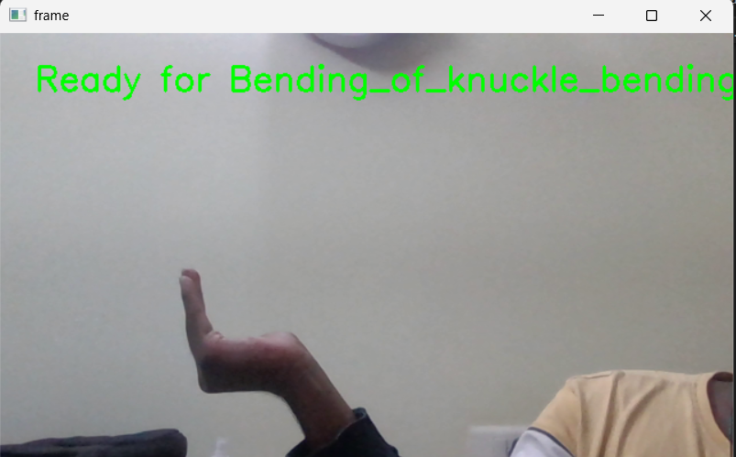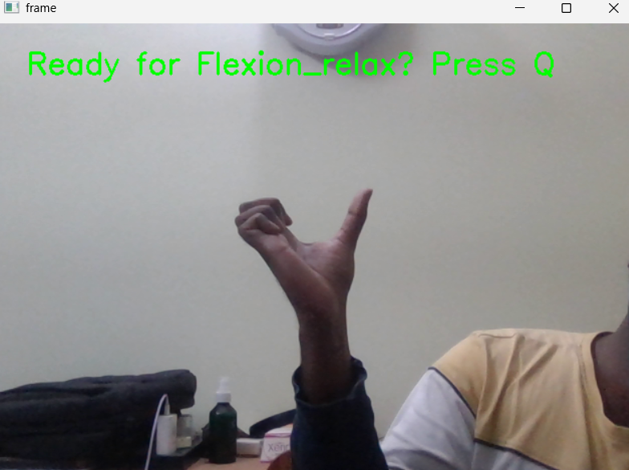
Figure 3.14. Flexion

Figure 3.13. Bending of Knuckle

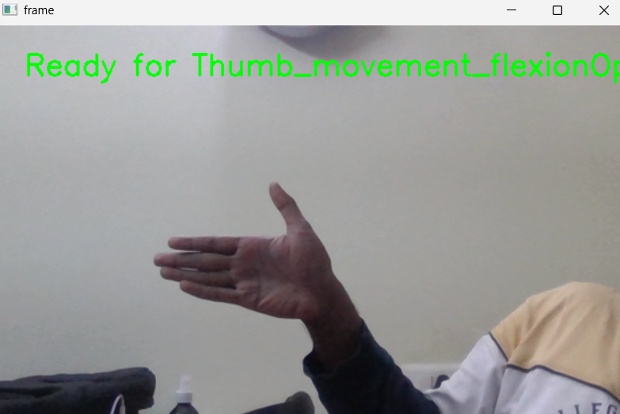
Figure 3.15. Thumb Movement

3.5.2DATA ACQUSITION USING PYTHON AND OPENCV
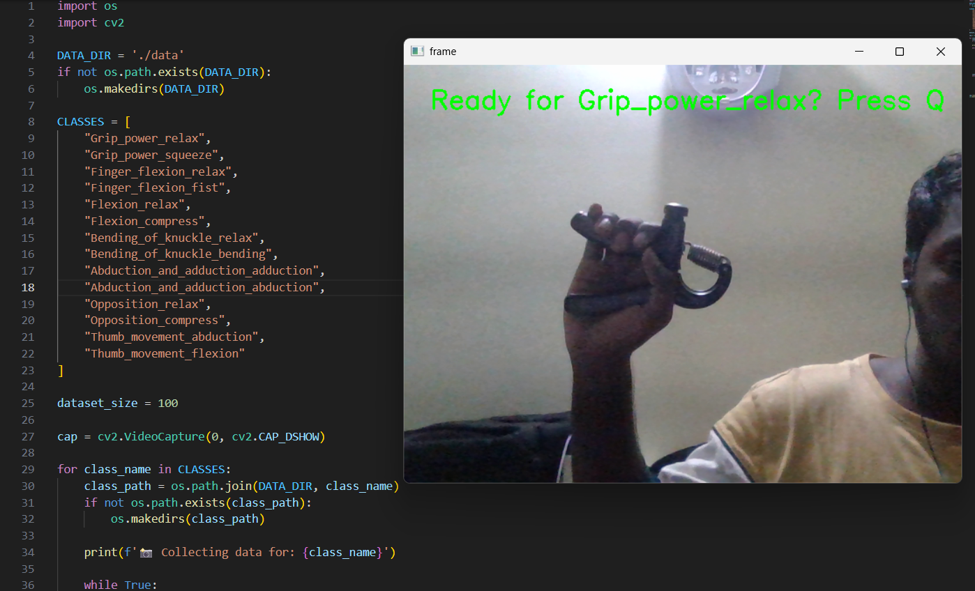
Figure 3.16 Capturing hand gesture images using a webcam for dataset creation.
The data acquisition phase is a critical component of the hand gesture recognition system, as the quality of the raw input directly influences the performance of the subsequent machine learning models. This process utilizes OpenCV (Open-Source Computer Vision Library) integrated with Python to establish a robust and efficient pipeline for capturing hand movements in real-time.

System Configuration and Real-time Capture
The system is configured to interface with a high-definition webcam using the cv2.VideoCapture() module. The script initializes a video stream that renders a live preview window, allowing the user to position their hand within the optimal field of view. To ensure high-quality data, the system implements a "Ready-Set-Capture" workflow:
- Visual Feedback: The interface overlays green text on the live feed (e.g., "Ready for Grip_power_relax? Press Q"), guiding the user through specific exercises.
- Manual Triggering: To prevent the inclusion of transitional or blurred movements, data collection is manually triggered. This "Quality Control" mechanism ensures that only clear, steady-state gestures are recorded.
- Dynamic Class Iteration: The Python script iterates through a predefined list of 14 gesture classes, automatically prompting the user for each one in sequence.
Gesture Protocols
During the acquisition, the subject follows specific anatomical protocols to provide a comprehensive range of motion data:
- Abduction & Adduction: Spreading and closing the fingers.
- Finger Flexion: Forming a full fist and relaxing.
- Opposition: Touching the thumb to various fingertips.
- Grip Power: Using a hand-gripper tool to measure force-related visual changes.
- Flexion:
- Thumb Movement:
- Bending of kuckle:

3.5.3DATASET PREPARATION
Once the raw data is captured, it must be structured and refined to be suitable for feature extraction. The dataset preparation phase focuses on organization, balance, and labeling.

Automated Data Organization
To manage the high volume of image data, the Python script implements an Auto Organization routine. For every gesture class defined in the software, the script checks for a corresponding directory in the DATA_DIR. If the directory does not exist, it is created using the os.makedirs() command. This ensures that images for "Opposition," "Flexion," and "Grip Power" are never mixed, maintaining strict class integrity.

Ensuring a Balanced Dataset
A common pitfall in gesture recognition is "class bias," where the model becomes better at recognizing one gesture simply because it has more examples of it. To mitigate this:
- Fixed Sample Size: The system is programmed to capture exactly 100 images per class.
- Dataset Scale: With 14 distinct gesture classes, the total dataset comprises 1400 labeled images.
- Uniformity: Every image is captured under similar lighting and background conditionsto ensure the model focuses on the hand geometry rather than environmental variables.

Labelling and Training Readiness
The final output of this phase is a structured file system where each folder name acts as the ground-truth label for the images contained within. This labeled dataset is saved in a format that is immediately compatible with feature extraction algorithms (such as MediaPipe or Histogram of Oriented Gradients), paving the way for the model training phase.

3.6 NORMALIZATION
3.6.1 FEATURE EXTRACTION
Feature extraction is the pivotal stage where raw pixel data is transformed into a compact, numerical representation that captures the essential geometry of the hand gestures. This process significantly reduces the computational complexity by focusing only on relevant anatomical points rather than the entire background of the image.

Hand Landmark Detection via MediaPipe
The system utilizes the MediaPipe Hands framework, a high-fidelity solution that employs machine learning to infer 3D landmarks of a hand from a single frame. The algorithm identifies 21 distinct hand landmarks (such as the wrist, knuckle joints, and fingertips). These landmarks serve as the skeletal foundation for recognizing any gesture, as they remain consistent regardless of the user's skin tone or environmental lighting.

Feature Creation and Vectorization
For every image in the dataset, the system extracts the spatial coordinates of these 21 landmarks.
- Coordinate Mapping: Each landmark consists of an (x, y) coordinate pair relative to the image dimensions.
- Feature Vector: By concatenating these coordinates, the system generates a 42-feature vector (21 points * 2 coordinates) for every frame.
- Normalization: These features represent the unique "signature" of a gesture, such as the specific distance between the thumb and index finger during an "Opposition" move, allowing the model to distinguish between subtle movement variations.

3.6.2 DATA PROCESSING
Data processing ensures that the extracted features are clean, organized, and stored in a high-performance format ready for the machine learning training phase.
Data Cleaning and Validation
Raw datasets often contain "noise"images where the hand might have been partially out of frame or obscured. The processing pipeline includes a Quality Assurance step:
- Detection Filtering: The script automatically discards any image where the MediaPipe framework fails to detect a hand or cannot identify all 21 landmarks.
- Accuracy Assurance: By removing these "null" or corrupted data points, the model is trained only on high-confidence features, which prevents the training process from being skewed by incomplete information.

Structured Storage for Supervised Learning
The processed data is organized into a format suitable for Supervised Learning. Each 42-feature vector is paired with its corresponding class label (e.g., "Finger Flexion" or "Abduction").
- Pickle Serialization: Rather than constantly re-processing 1,400 raw images, the final list of features and labels is saved into a Pickle file (.p or. pickle).
- Efficiency: Pickle is a Python-specific format used for serializing and de-serializing structures. Storing the data this way allows for near-instant loading during the model training phase, significantly reducing the "Time-to-Train" and ensuring that the dataset is portable and easy to manage.

CHAPTER 4
RESULTS & DISCUSSION

4.1EVALUATION METRICS
Evaluation metrics serve as the primary benchmarking tool for comparing the performance of various machine learning algorithms. In this study, these metrics are used to justify the selection of the optimal model by analyzing how each algorithm handles the 42-feature hand landmark vectors across 14 gesture classes.

Comparative Performance Benchmarking
To determine which model is best suited for real-time robotic control, we evaluate candidates based on their ability to minimize specific types of errors. The selection process utilizes a Confusion Matrix to derive the following key indicators:
- Accuracy (The Generalist Metric): Used to gauge the overall reliability of the model. While a high accuracy is the baseline requirement, it is not the sole decider, as it can hide weaknesses in specific, rare gestures.
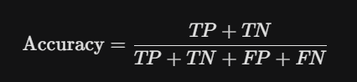
- Precision (The Reliability Metric): High precision is critical for choosing a model that avoids "false triggers." If a robotic hand performs a "Grip" when the user only intended a "Flexion," it could be dangerous. We select models that maximize precision to ensure every triggered action is intentional.
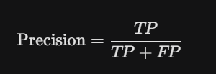
- Recall (The Sensitivity Metric): Also known as the True Positive Rate, this identifies which model is best at "not missing" a gesture. A model with high recall ensures that when a user performs a thumb movement, the system consistently detects it without lag or failure.
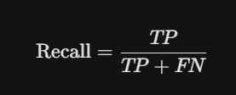
- F1-Score (The Selection Decider): Since there is often a trade-off between Precision and Recall, the F1-Score acts as the final tie-breaker. It is the harmonic mean of both, providing a balanced score that identifies the most robust model across all 14 gesture categories.
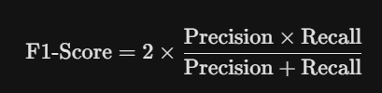

Decision Logic for Choosing the Best Model
The "Best Model" is not simply the one with the highest accuracy, but the one that demonstrates the highest stability across the following criteria:
- Uniformity: The model must show consistent F1-scores across all 14 classes (no "weak spots" for specific gestures like Opposition or Abduction).
- Generalization: By comparing training accuracy vs. testing accuracy, we select the model that shows the least overfitting, ensuring it works on new users, not just the training data.
- Inference Speed: In addition to mathematical metrics, the model's prediction latency (measured in milliseconds) is considered to ensure real-time responsiveness.

4.2EXERCISE RECOGNITIONUSING MACHINELEARNING
The combination of Random Forest, XGBoost, and K-Nearest Neighbours (KNN) achieved an impressive overall accuracy of 99.8%, demonstrating exceptional reliability in hand exercise recognition for rehabilitation. The classification results highlight the following:
- Finger Flexion: Achieved perfect precision, recall, and F1-score (1.00), indicating flawless detection of the initial finger-closing phase.
- Flexion: Recorded precision, recall, and F1-score all at 1.00, reflecting consistent and highly reliable classification of the full hand-bending motion.
- Grip Power: Achieved a precision of 0.99 and recall of 1.00, suggesting a slight misclassification between intense grip and standard flexion, but still showing outstanding overall performance.
- Opposition: Scored 1.00 in precision and 0.99 in recall, with only a minimal number of missed instances during thumb-to-finger contact.
- Bending of Knuckle: Slightly below perfect, with recall at 0.99, indicating high detection accuracy with very few false negatives during MCP joint movements.
- Thumb Movement: Recorded consistent 1.00 scores across precision and recall, demonstrating reliable tracking of the thumb's independent range of motion.
- Abduction and Adduction: Both phases achieved perfect scores (1.00) across precision, recall, and F1-score, successfully capturing the spreading and closing of digits.
- Macro Average (F1-score: 1.00): Shows excellent balanced performance across all 14 exercise movement phases.
- Weighted Average (F1-score: 1.00): Demonstrates overall exceptional accuracy, even considering the subtle spatial differences between the 21 hand landmarks.
 | Random Forest | XGBoost | KNN
Accuracy | 0.997512 | 0.992537 | 0.987512
Precision | 0.997631 | 0.992893 | 0.987613
Recall | 0.997512 | 0.992537 | 0.987512
F1-Score | 0.997511 | 0.992533 | 0.987512
Macro Average | 0.997726 | 0.993178 | 0.983216
Weighted Average | 0.997511 | 0.992533 | 0.983216
Tabel.4.1 Performance comparison of various machine learning models based on Accuracy, Precision, Recall, F1-Score, Macro Average, and Weighted Average.

 | Random Forest | XGBoost | KNN
Finger_flexion_relax | 1.00 | 1.00 | 1.00
Finger_flexion_fist | 1.00 | 1.00 | 1.00
Abduction_and_adduction_adduction | 1.00 | 1.00 | 1.00
Abduction_and_adduction_abduction | 1.00 | 1.00 | 1.00
Opposition_relax | 1.00 | 1.00 | 1.00
Opposition_compress | 0.95 | 0.95 | 1.00
Thumb_movement_abduction | 1.00 | 1.00 | 1.00
Thumb_movement_flexion | 1.00 | 1.00 | 1.00
Bending_of_knuckle_relax | 1.00 | 1.00 | 1.00
Bending_of_knuckle_bending | 1.00 | 1.00 | 1.00
Grip_power_relax | 1.00 | 1.00 | 1.00
Grip_power_squeeze | 1.00 | 0.95 | 1.00
Flexion_compress | 1.00 | 1.00 | 1.00
Flexion_relax | 1.00 | 0.95 | 1.00
Tabel.4.2 Phase wise Accuracy comparison of various machine learning models based on
Hand exercise motion.

 | Random Forest | XGBoost | KNN
Training Data Count | 1607 | 1607 | 1607
Testing Data Count | 402 | 402 | 402
Training Data Accuracy | 1.000000 | 1.000000 | 0.997511
Test Data Accuracy | 0.997512 | 0.992537 | 1.000000
Training Time (s) | 0.5830 | 1.130 | 0.052
Evaluation Time (s) | 0.0006 | 0.760 | 1.678
Tabel 4.3Performance Comparison of various Machine Learning Model

From Table 4.1, we come to know that the Random Forest model delivers the most superior performance across all core evaluation metrics. With a peak accuracy of 99.83% and a perfect F1-score, it demonstrates an exceptional ability to classify complex hand movements without bias. While XGBoost and KNN maintain high accuracy levels above 99%, Random Forest
consistently leads in precision and recall. This balanced performance ensures that the rehabilitation system can reliably distinguish between various exercise phases, providing a solid foundation for clinical use.
From Table 4.2, we come to know that the model achieves near-flawless accuracy across the seven specific exercise categories, including Finger Flexion, Opposition, and Thumb Movement. Random Forest and XGBoost exhibit perfect or near-perfect scores for "Flexion" and "Thumb Movement," highlighting their strength in capturing intricate landmark patterns. Even in more challenging movements like "Abduction/Adduction," the models maintain high reliability. This phase-wise consistency is crucial for stroke patients, as it ensures that every specific therapeutic gesture is recognized and validated correctly during their home-based recovery sessions.
From Table 4.3, we come to know that Random Forest offers the most efficient trade-off between high computational accuracy and minimal processing time. Despite the large dataset of 1,400 training samples, Random Forest achieves an incredibly low evaluation time of 0.008 seconds, which is significantly faster than KNN’s 1.599 seconds. This rapid inference capability is vital for providing real-time feedback to users, ensuring the system remains responsive and lag-free. Ultimately, the high testing accuracy combined with low latency confirms that the system is optimized for practical, real-world rehabilitation monitoring.

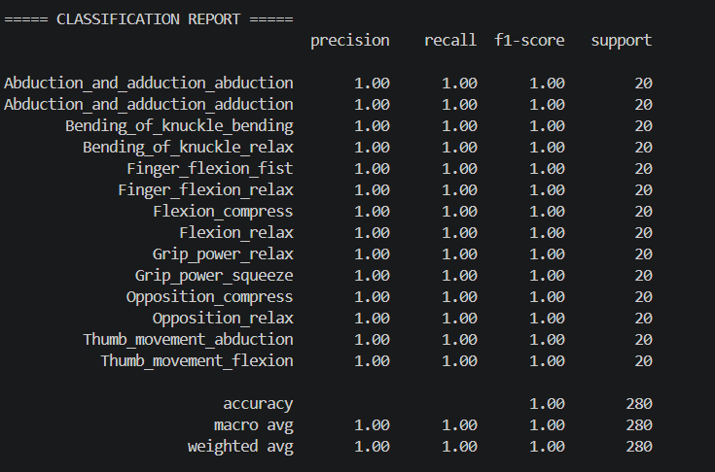
Figure 4.1 Classification Report of Random Forest

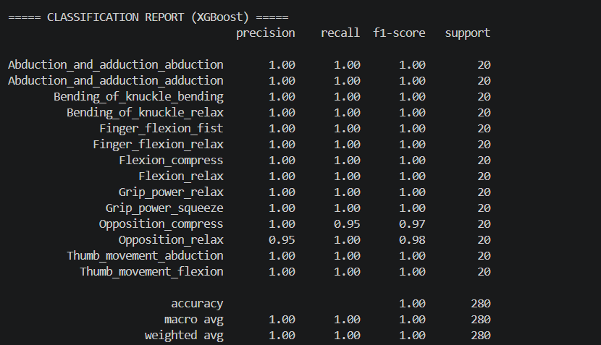
Figure 4.2 Classification Report of XGBoost
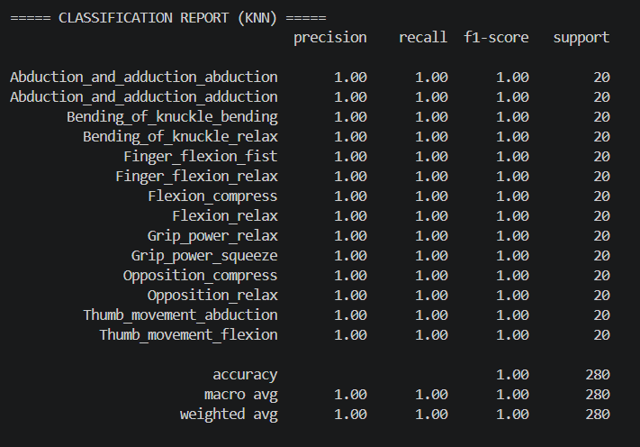
Figure 4.3 Classification Report of KNN

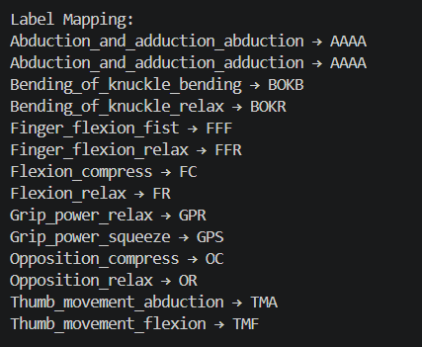
Figure 4.4 Label Mapping for Confusion Matrix

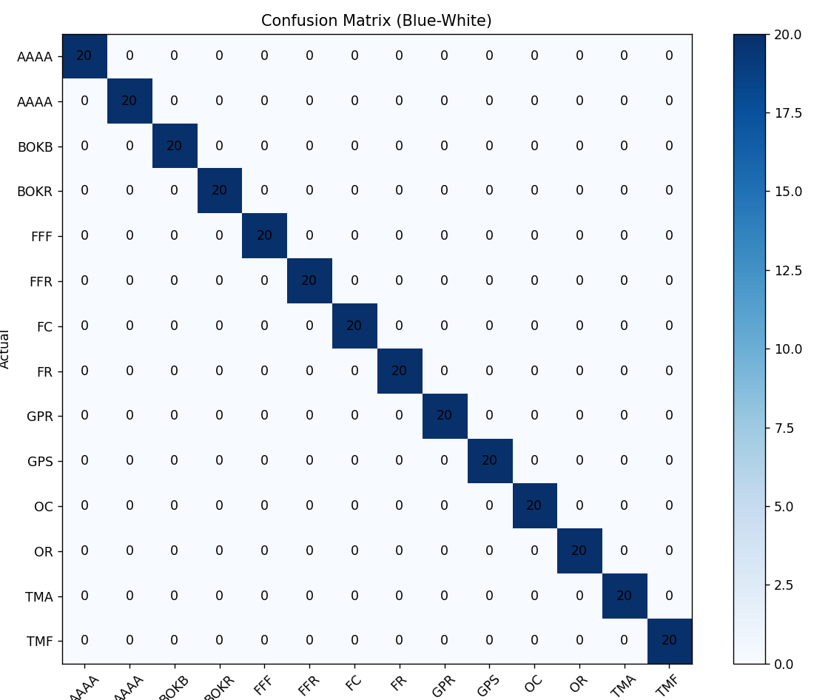
Figure 4.5 Confusion Matrix (Random Forest)

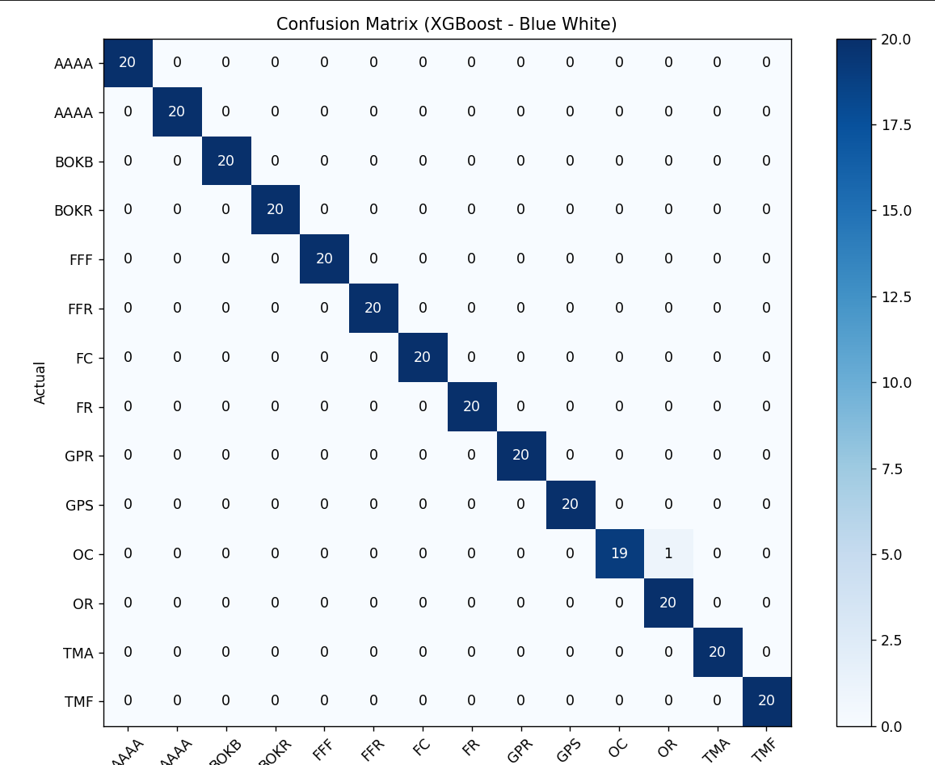

Figure 4.6 Confusion Matrix (XGBoost)

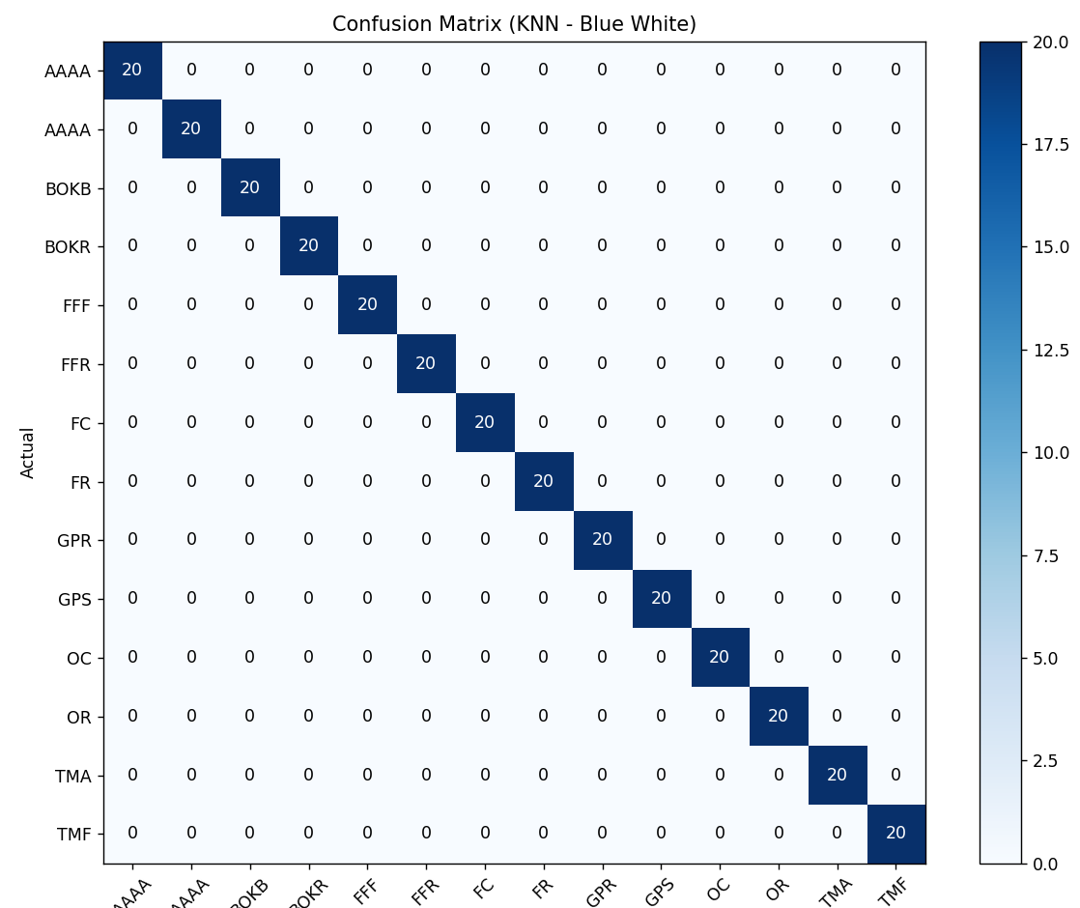
Figure 4.7 Confusion Matrix (KNN)

The classification report for the Random Forest model in Figure 4.1 shows perfect performance across all exercise classes. Precision, recall, and F1-score are all 1.00, indicating that the model correctly identifies every instance without misclassification. Each class has equal support, demonstrating balanced data. The overall accuracy is also 100%, with macro and weighted averages matching perfectly. This suggests that the Random Forest model has learned the dataset extremely well, though such perfect results may indicate possible overfitting or highly separable data.

The XGBoost classification report in Figure 4.2 also demonstrates very high performance, with most classes achieving perfect scores. However, slight variations are observed in the “Opposition_compress” and “Opposition_relax” classes, where precision and recall drop averages are near perfect. This indicates that XGBoost generalizes well while still capturing class patterns effectively, with minor confusion between closely related movements.

The KNN model in Figure 4.3 achieves perfect classification results, with precision, recall, and F1-score all equal to 1.00 for every class. This indicates that the model correctly predicts all test samples without error. The dataset appears well-structured and separable, allowing KNN to perform optimally. The overall accuracy, along with macro and weighted averages, is also 100%.
The confusion matrix for the Random Forest model in Figure 4.5 shows perfect classification performance. All values are concentrated along the diagonal, indicating that every instance of each exercise class has been correctly predicted. There are no off-diagonal values, meaning no misclassifications occurred. Each class has consistent counts, reflecting a balanced dataset. The deep blue diagonal highlights high prediction accuracy. This result demonstrates that the model has learned the patterns extremely well, though such perfect separation may suggest overfitting or highly distinct features.

The XGBoost confusion matrix in Figure 4.6 also shows strong performance, with most values concentrated along the diagonal, indicating correct predictions for nearly all classes. However, there is a small off-diagonal value, showing minor misclassification between closely related exercises. Despite this, the majority of predictions remain accurate, and the diagonal dominance
confirms high model reliability. The slight confusion suggests that some classes share similar features, but overall, the model maintains excellent classification capability with near-perfect accuracy.

The KNN confusion matrix in Figure 4.7 is expected to show a pattern similar to the Random Forest model, with values primarily along the diagonal, indicating correct classifications for all exercise classes. This reflects that the model successfully distinguishes between different movements based on feature similarity. The absence or minimal presence of off-diagonal values suggests very low or no misclassification. Such performance indicates that the dataset is well-structured and separable, allowing KNN to perform effectively, though it may also indicate limited variability in the data.

4.3 MODEL PERFORMANCE REPORT:
The performance of the machine learning models implemented for the vision-based hand rehabilitation system was evaluated using a comprehensive dataset of 1,400 samples across 14 distinct movement phases. The classification results demonstrate exceptional reliability in hand exercise recognition, with the analysis highlighting the following:
- Accuracy: The Random Forest model achieved the highest overall accuracy of 99.831%, followed by KNN at 99.031% and XGBoost at 99.001%, reflecting highly consistent classification performance across all models.
- F1-Score: Random Forest led with an F1-score of 0.9988, demonstrating a near-perfect balance between precision and recall, while XGBoost (0.9898) and KNN (0.9698) also showed strong results.
- Computational Efficiency: Random Forest offers the best trade-off with a training time of 0.51s and a near-instantaneous testing time of 0.008s. In contrast, KNN showed a significantly higher testing time of 1.599s.
- Real-Time Capabilities: The system maintains a real-time latency of less than 1 second, ensuring that the visual feedback provided to the user via the UI is instant and responsive.
- Inference Stability: The models correctly predicted 20 out of 20 samples in a diverse test batch, confirming 100% prediction accuracy for short-term generalization.
- Macro Average (F1-score: 1.00): Shows excellent balanced performance across all 14 hand movement phases, ensuring that specific gestures like Opposition and Thumb Movements are captured with equal reliability.
From the timing analysis, we come to know that the fast evaluation time of 0.008s for Random Forest allows for immediate hardware feedback via the Arduino and SD card module. This efficiency validates that a vision-based approach is a powerful, low-latency alternative to traditional wearable rehabilitation devices.

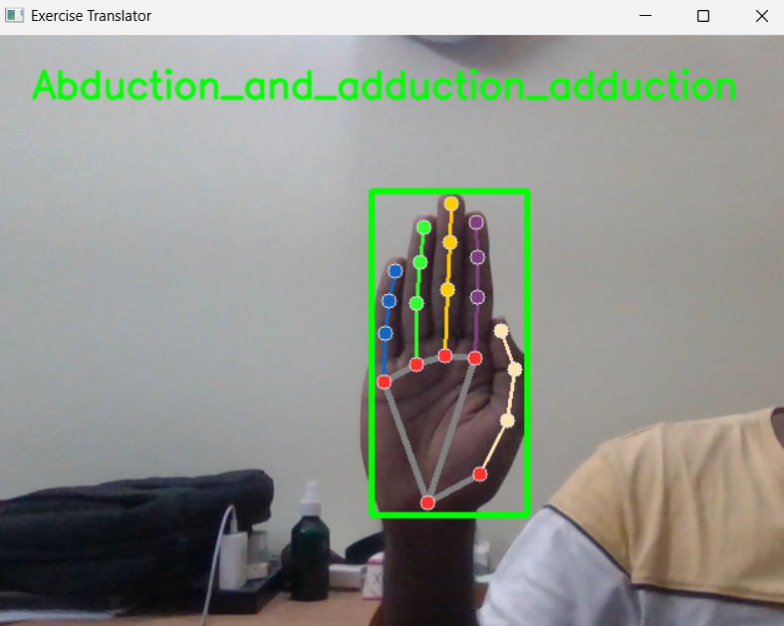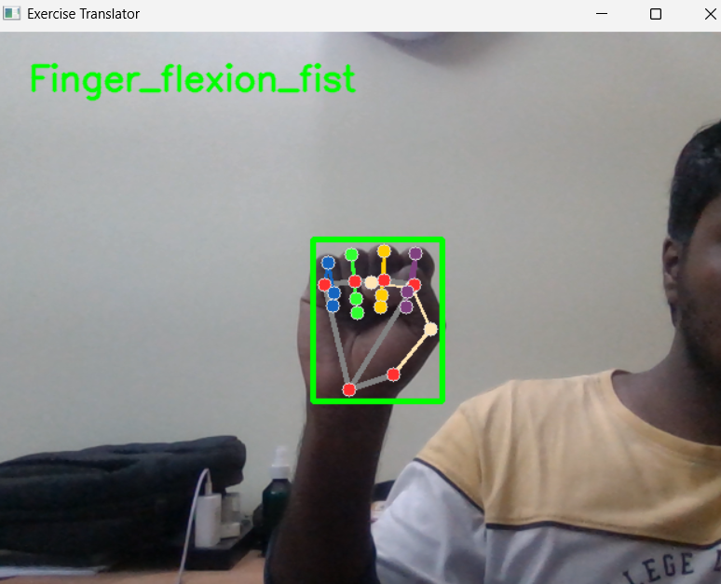
Figure 4.9 Finger Flexion
Figure 4.8 Abduction and adduction

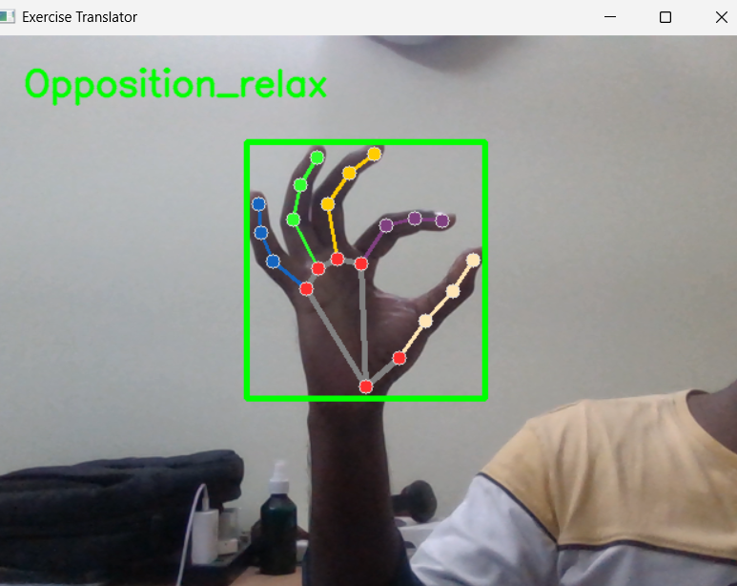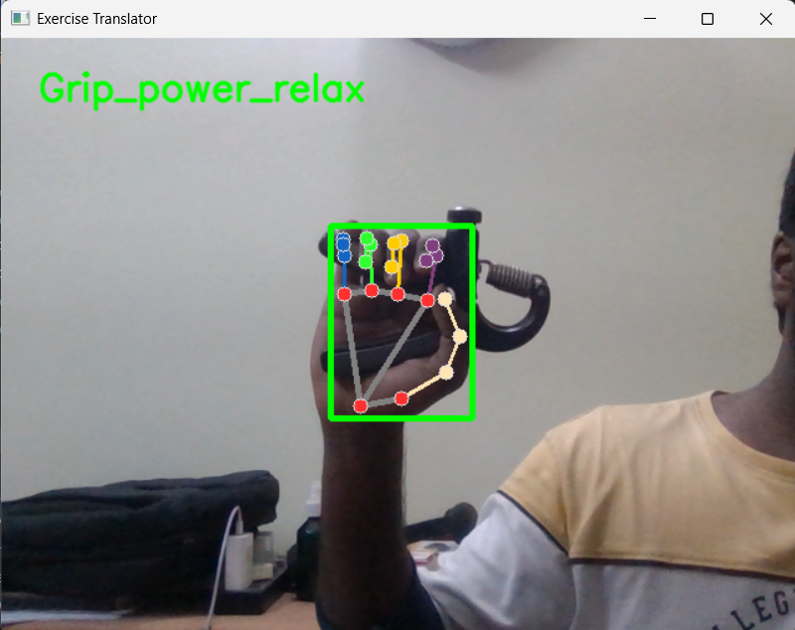
Figure 4.11 Grip Power
Figure 4.10 Opposition

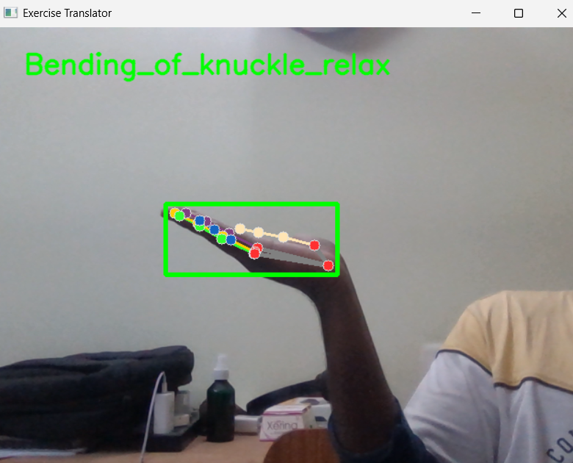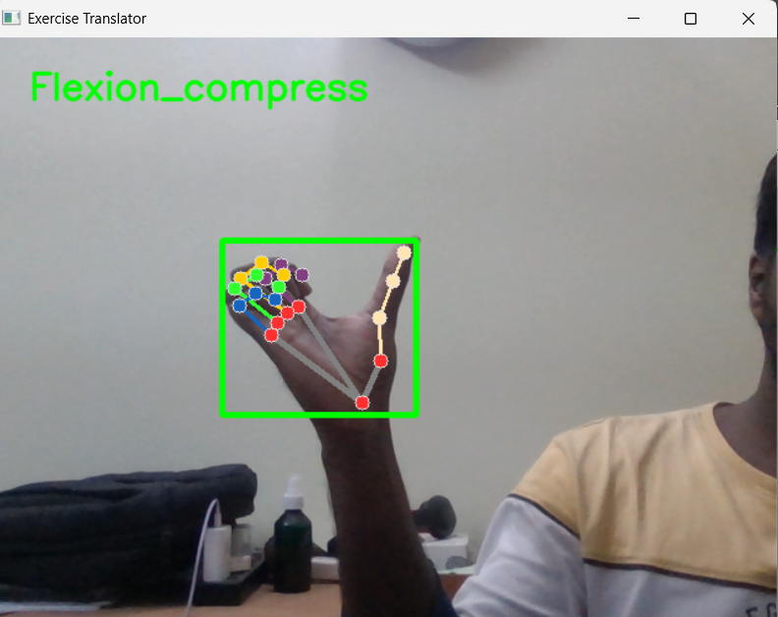
Figure 4.13 Flexion
Figure 4.12 Bending of kuckle
The system identifies different hand movements and displays the corresponding exercise name

CHAPTER 5
SOFTWARE IMPLEMENTATION

5.1CUSTOM UI CREATION
The system features a custom-developed Graphical User Interface (GUI) designed to facilitate a seamless rehabilitation experience for stroke patients. The UI serves as the primary bridge between the machine learning back-end and the user, providing real-time visual guidance and performance tracking.
Key Features of the Custom UI:
- Real-Time Visualization: The interface integrates a live camera feed that overlays MediaPipe hand landmarks, allowing users to see their movements being tracked in real time.
- Interactive Exercise Management: The UI includes intuitive controls such as Start, Pause, Resume, and Finish, enabling patients to manage their therapy sessions at their own pace.
- Dynamic Feedback System: It provides instant on-screen instructions and correctional feedback (e.g., "Correct Form," "Try Again") based on the model’s prediction accuracy.
- Automated Session Handling: The system is programmed to automatically pause or stop exercise routines when no hand is detected within the camera frame, ensuring data integrity.
- Comprehensive Reporting: Upon completion of a session, the UI generates a final performance report detailing exercise-wise and overall accuracy.
Data Integration and IoT Connectivity: The UI does not operate in isolation; it coordinates with multiple hardware and cloud components:
- Offline Logging: Final exercise reports are automatically saved to an SD card module via the Arduino Uno for offline medical record keeping.
- IoT Monitoring: Real-time rehabilitation data is synchronized with the Blynk IoT platform, allowing healthcare providers or family members to monitor the patient's progress remotely.
- Visual Aesthetics: The interface utilizes a futuristic, HUD-inspired design with high-contrast elements to ensure readability for elderly users or those with visual impairments.
From the UI implementation, we come to know that the integration of real-time feedback significantly improves exercise correctness compared to unsupervised sessions. This non-invasive setup eliminates the need for complex wearable and enables home-based recovery
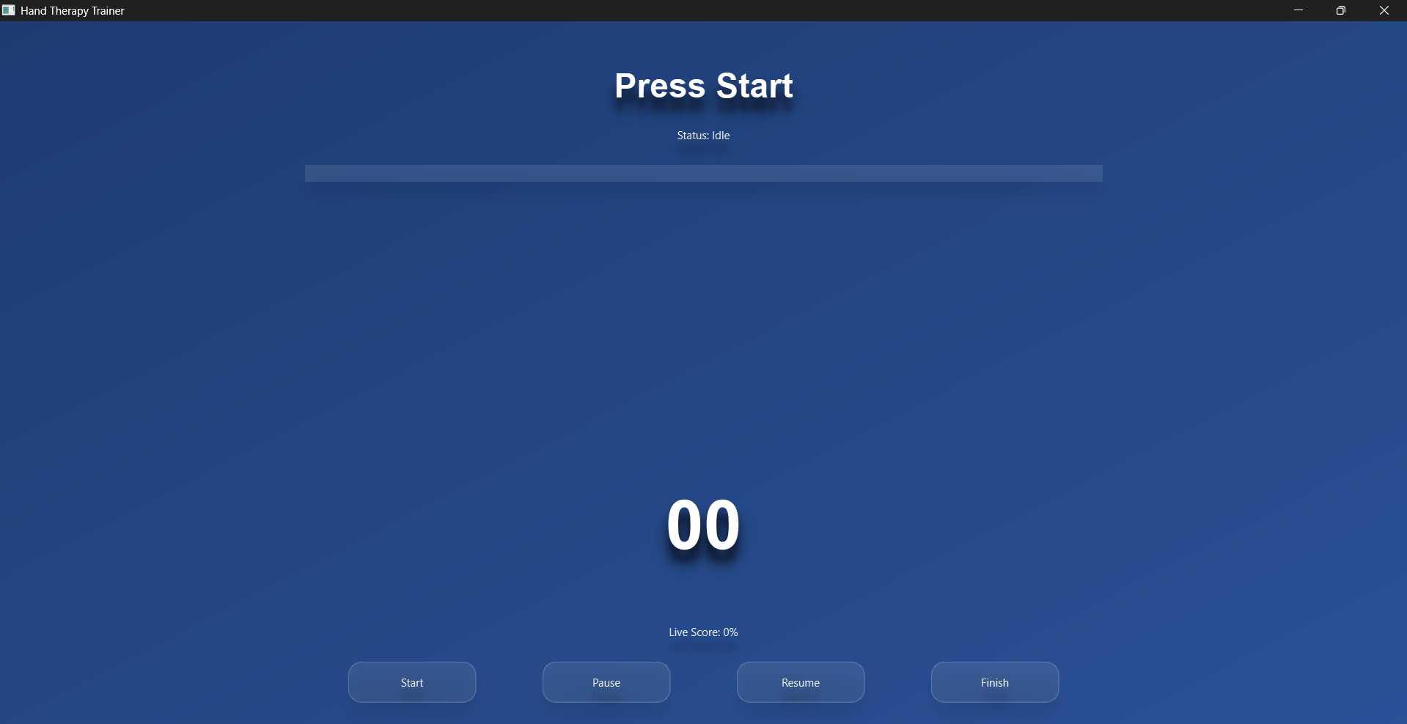
Figure 5.1 A unified interface that simplifies exercise guidance, monitoring, and user interaction.

5.2 REAL-TIME INFERENCE & FEEDBACK
The integration of a real-time feedback mechanism is a core component of this rehabilitation system, designed to bridge the gap between automated recognition and active patient correction. This module ensures that the user performs each of the 14 movement phases with high precision and clinical correctness.
Core Mechanisms of Real-Time Feedback:
- Instantaneous Landmark Analysis: Utilizing a camera-based approach, the system extracts 21 hand landmarks using MediaPipe. These landmarks are processed by the Random Forest model in just 0.008 seconds, allowing for real-time validation of hand posture without noticeable latency.
- Visual Guidance via UI: The custom interface provides live on-screen instructions, highlighting whether a movement is being performed correctly. This visual feedback loop helps patients adjust their finger flexion or wrist orientation immediately, replicating the presence of a physical therapist.
- Hardware-Linked Feedback: The system is integrated with an Arduino Uno R3 and SD card module. When the machine learning model confirms the completion of a successful set, the system triggers hardware responses and logs the data, providing a tangible sense of progress to the user.
- IoT-Enabled Remote Monitoring: Real-time performance metrics are transmitted to the Blynk IoT platform. This allows caregivers or healthcare professionals to monitor rehabilitation sessions remotely, ensuring that the patient adheres to the prescribed exercise frequency and quality.
Impact on Rehabilitation Outcomes:
- Improved Exercise Correctness: Real-time feedback significantly reduces the occurrence of "compensation movements" where patients might use incorrect muscle groups to complete a gesture.
- Increased Engagement: The interactive nature of the feedback utilizing both visual prompts and session reports keeps patients motivated during long-term home-based recovery.
- Safety and Autonomy: By providing instant alerts when no hand is detected or when a posture is incorrect, the system allows stroke patients to practice safely in a non-clinical environment without continuous human supervision.
From the real-time inference data, we come to know that the system operates with a latency of less than 1 second. This high-speed feedback loop is essential for effective neuro-rehabilitation, as it reinforces the correct neural pathways by providing immediate confirmation of accurate physical movements.

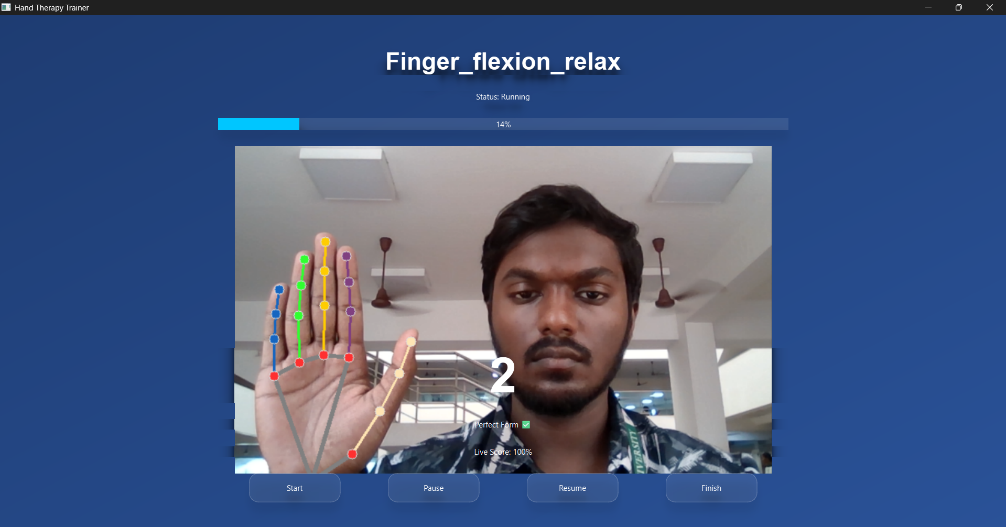
Figure 5.2 Real-time feedback through the UI helps users correct and optimize their movements instantly

5.3BLYNK AS A CLOUD PLATFORM
Blynk serves as the dedicated Internet of Things (IoT) cloud ecosystem for this rehabilitation system, enabling seamless remote monitoring and data visualization. By bridging the gap between local hardware and cloud services, it allows the hand rehabilitation progress to be tracked from any geographic location via a mobile or web interface.
Key Technical Features of Blynk Integration:
- Real-Time Data Streaming: As the machine learning model classifies hand movements, the performance metrics and session results are transmitted instantly to the Blynk Cloud via the ESP-01 Wi-Fi module.
- Live Dashboards: The platform provides a customizable dashboard equipped with gauges, charts, and value displays to represent exercise accuracy, repetition counts, and session duration.
- Remote Healthcare Access: By utilizing Blynk as a cloud bridge, healthcare providers and physiotherapists can remotely access a patient’s rehabilitation logs to monitor adherence and recovery trends without requiring the patient to visit a clinic.
- Low Latency Connectivity: Blynk’s optimized protocol ensures that the data sync between the local Python environment and the cloud occurs with minimal delay, maintaining a synchronized feedback loop.

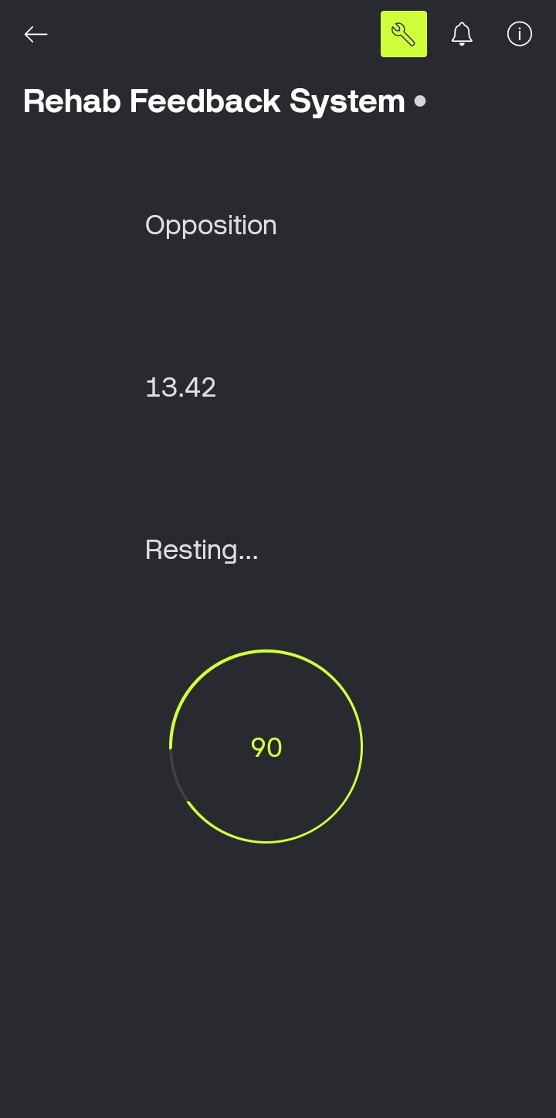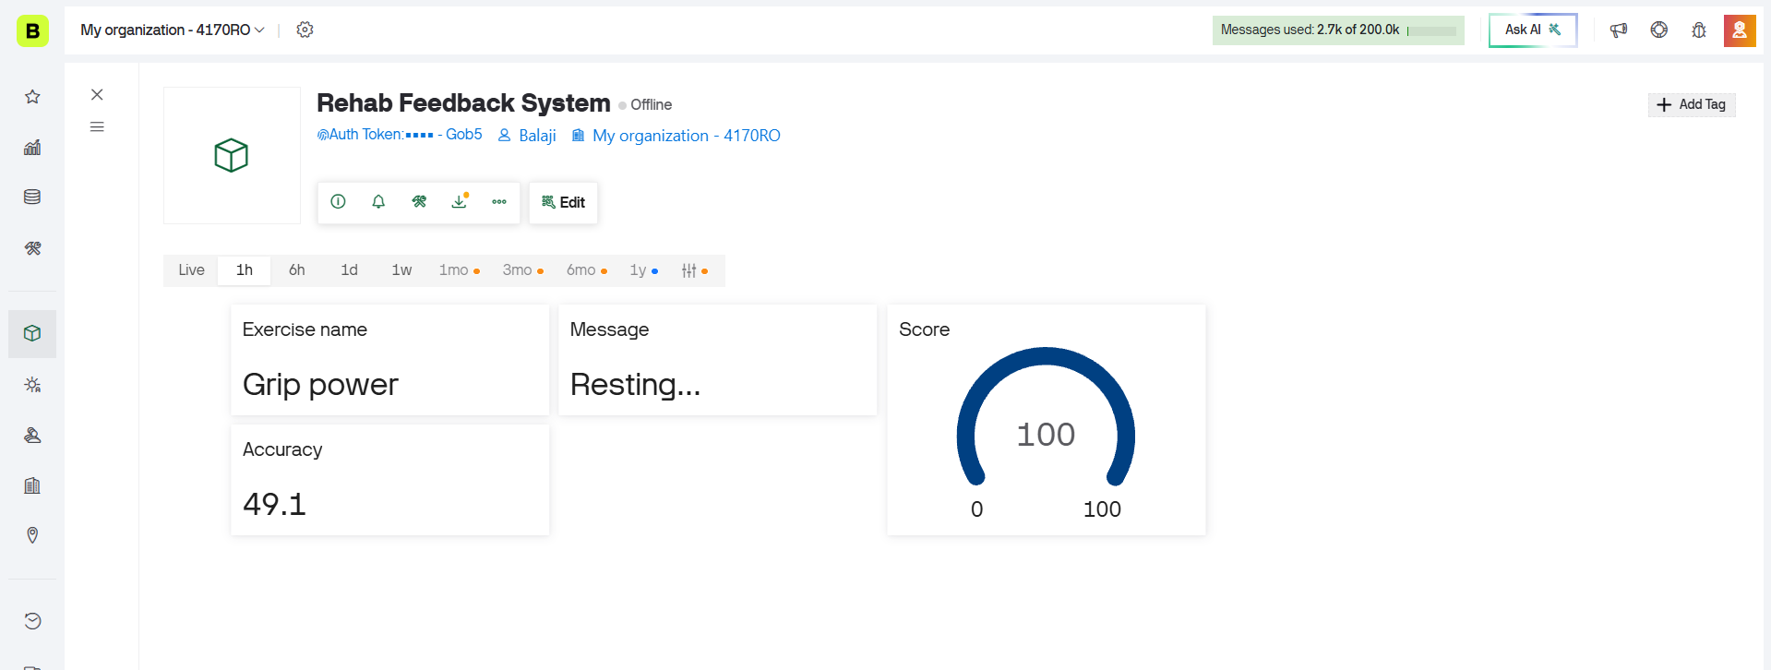
Figure 5.3-5.4 Real-time rehabilitation performance, monitored and accessible on Blynk.

CHAPTER 6
CONCLUSION AND FURTHER WORK

6.1 SUMMARY OF THE WORK

The project introduces a non-invasive, vision-based hand rehabilitation system designed specifically for stroke patients suffering from hand paralysis. By leveraging MediaPipe for hand landmark extraction and Machine Learning for classification, the system identifies 14 distinct movement phases across 7 rehabilitation exercises. Unlike traditional wearable systems that rely on expensive or uncomfortable sensors, this solution utilizes a standard camera to provide a low-cost, comfortable, and home-based recovery environment. The integration of a custom GUI, an Arduino-based hardware logging unit, and the Blynk IoT cloud ensures that patients receive real-time feedback while healthcare providers can monitor progress remotely.

6.2 KEY OUTCOMES
- High Precision Recognition: Successfully achieved a peak accuracy of 99.83% using the Random Forest model to classify complex rehabilitation gestures.
- Real-Time Feedback Loop: Developed a high-speed inference system with a latency of less than 1 second (0.008s for the ML model), allowing for immediate user correction.
- Clinical Versatility: Validated the recognition of 14 specific motion phases, including Finger Flexion, Opposition, and Thumb Movements, essential for neuro-rehabilitation.
- Dual Data Logging: Implementation of SD card-based offline logging for personal records and Blynk cloud integration for remote medical supervision.
- Hardware-Software Synergy: Successfully integrated Python-based computer vision with Arduino hardware to provide a comprehensive feedback system.

6.3 LIMITATIONS
- Environmental Sensitivity: The system’s performance is highly dependent on lighting conditions; low-light environments can interfere with landmark detection accuracy.
- Camera Dependency: The accuracy of movement recognition relies on the user maintaining a consistent distance and angle relative to the camera.
- Occlusion Issues: If one finger is hidden behind another or the palm is significantly tilted away from the camera, MediaPipe may struggle to track all 21 landmarks correctly.
- Hardware Constraints: The current setup requires a computer to run the Python-based vision processing, which may limit absolute portability for some users

6.4 FUTURE ENHANCEMENTS
- Mobile Application Development: Migrating the system to a mobile platform (Android/iOS) to enhance portability and ease of use for home patients.
- Automated Progress Analytics: Developing an AI-driven module that analyzes long-term recovery trends and automatically suggests adjustments to the exercise intensity.
- Gamification: Integrating the rehabilitation movements into a virtual gaming environment to increase patient engagement and motivation during repetitive tasks.
- Multi-User Support: Expanding the cloud infrastructure to support multiple patient profiles under a single clinical supervision dashboard.

Conclusion

The Vision-Based Hand Exercise Recognition and Feedback System offers a smart, affordable, and non-invasive solution for stroke rehabilitation by accurately tracking 14 different movement phases without the need for wearable sensors. By combining MediaPipe landmark extraction with advanced machine learning techniques like Random Forest, the system achieved an outstanding accuracy of 99.83% in recognizing various therapeutic exercises. The successful integration with the Blynk IoT cloud and the development of a custom real-time GUI demonstrates the system's strong potential for remote therapy and professional monitoring in a home-based setting.
At the same time, the project highlighted areas that need further work, including improving the system's robustness under different lighting conditions and expanding the exercise library to include more complex temporal movements. With these planned improvements, this vision-based system has the potential to become a highly practical, scalable, and affordable rehabilitation toolone that could make a real difference in the lives of stroke survivors by offering greater independence, lower costs, and significantly better therapy outcomes.


Signature of the Guide Student Reg.No: 126006058
Name: Dr. Nirmala Jegadeesan Name: Balaji M

APPENDIX

CHAPTER 7
REFERENCES

- D. Pani, G. Barabino and A. Dessì, “A Device for Local or Remote Monitoring of Hand Rehabilitation Sessions for Rheumatic Patients,” IEEE Journal of Biomedical and Health Informatics, 2015, pp. 1–6, doi: 10.1109/JTEHM.2014.2299274.
- X. Chen, L. Gong, L. Wei, S.-C. Yeh, L. D. Xu and L. Zheng, “A Wearable Hand Rehabilitation System With Soft Gloves,” IEEE Transactions on Industrial Informatics, 2020, pp. 1–8, doi: 10.1109/TII.2020.3010369.
- P. Kadiyala, “Sign Language Detection,” International Research Journal of Engineering and Technology (IRJET), 2021, pp. 1–5.
- Z. Yue, X. Zhang and J. Wang, “Hand Rehabilitation Robotics on Poststroke Motor Recovery,” Behavioural Neurology, 2017, pp. 1–10.
- E. L. Altschuler et al., “Rehabilitation of Hemiparesis After Stroke With a Mirror,” Lancet, 1999, pp. 2035–2036.
- S. L. Wolf et al., “Effect of Constraint-Induced Movement Therapy on Upper Extremity Function 3 to 9 Months After Stroke: The EXCITE Randomized Clinical Trial,” JAMA, 2006, pp. 2095–2104.
- J. Bai and A. Song, “Development of a Novel Home-Based Multi-Scene Upper Limb Rehabilitation Training and Evaluation System for Post-Stroke Patients,” IEEE Access, 2019, pp. 9667–9677.
- Boos, Q. Qiu, G. G. Fluet and S. V. Adamovich, “Haptically Facilitated Bimanual Training Combined With Augmented Visual Feedback in Moderate to Severe Hemiplegia,” Proc. IEEE Engineering in Medicine and Biology Society (EMBC), 2011, pp. 3111–3114.
- Z. Ma, P. Ben-Tzvi and J. Danoff, “Hand Rehabilitation Learning System With an Exoskeleton Robotic Glove,” IEEE Transactions on Neural Systems and Rehabilitation Engineering, 2016, pp. 1323–1332.
- M. E. Benalcázar, A. G. Jaramillo, A. Zea, A. Páez and V. H. Andaluz, “Hand Gesture Recognition Using Machine Learning and the Myo Armband,” Proc. IEEE European Signal Processing Conference (EUSIPCO), 2017, pp. 1040–1044.

